Module Code | IY4113
Group | A
Module Title | Applied Software Engineering using Object-Orientated Programming
Assessment Type | Final Submission
Module Tutor Name | Jonathan Shore
Student ID Number | P489062
Date of Submission | 19/04/2026

☒ I confirm that this assignment is my own work. Where I have referred to academic sources, I have provided in-text citations and included the sources in the final reference list.

☒ Where I have used AI, I have cited and referenced appropriately.

Introduction

The purpose of this report is to chronicle the creation of a console-based public transport travel companion app that helps users keep track of fares, discounts and daily caps, and allows admins edit fare rules and configuration files. This is to aid in the development of the app, ensuring that it does not grow too large in scope, and to enable reflection that shall allow for improvements during the later stages of development. The report shall keep track of any and all third-party code used, as well as all instrumental technical elements. Test tables and annotation screenshots shall be included in the report in order to demonstrate the program’s efficacy. The report shall start with the analysis conducted to identify core program functionality as well as expected inputs and outputs. Then, the algorithm and design used to infer the development of the program shall be explored, followed by a testing table that shows the expected and actual outputs from each of the inputs, and whether or not the program functions as intended. Finally, a full evaluation of the program’s efficacy and shortcomings shall be conducted.

Purpose of the Program

Is to act as a public transport companion travel app that allows the user to keep track of their daily travels, allowing them to save the details of each individual journey, such as the starting zone, destination zone, whether the trip is during peak or off-peak times and the passenger type. The program shall calculate the base fare for the journey based on this information using a dataset (which is editable by administrators), before applying any valid discounts or caps. The program shall allow the user to log in as a rider by either creating a new profile (which shall capture the rider's name, passenger type and default payment option) or loading an existing profile. While logged into a rider profile, journeys shall be saved to that particular profile in JSON format Alternatively, the user shall be able to log into a password protected administrator mode which will allow them to view and edit fare rules, discounts, daily caps, and peak time windows. All changes shall be validated before being saved and enforced.

Core program functionality
- Support multiple roles
  - Allow the user to log in using a rider profile, loading all previous journeys made by that profile.
  - Allow the user to create a new rider profile, capturing and validating their name, passenger type, and default payment method.
  - Allow the user to log into a password-protected administartor mode, allowing them to edit the confdiguration file for the system, including fare rules, discounts, daily caps, and peak time windows. All changes shall be validated before being saved and enforced.
- Load config file
  - Load configuration data from a pre-existing JSON config file.
  - If the config file is missing, the system shall use safe values provided through a default dataset
- Manage journeys
  - Store multiple journeys, each with its own details (date, zones, passenger type, time band) as well as calculate the total.
  - Assign a unique ID to each journey.
  - Display summary (exported as a CSV file, and a text report) which includes:
    - Number of journeys
    - Total cost
    - Average cost per journey
    - Most expensive journey by charged fare, with ID
    - Whether cap was reached, and how much the rider saved due to the cap
    - Category counts: peak vs off-peak, counts per zone
  - Recalculate totals when necessary
  - Allow the import and export of journeys in CSV format.
  - Save journeys to their respective rider in JSON format.
- Display user menu
  - Show a simple menu that allows the user to choose what they'd like to do.
  - Have clear prompts to signify successful actions.
  - Loop the menu until the user exists.
- Allow the user to manage journeys
  - Remove journeys from the list using its ID.
  - Add multiple journeys per session.
  - List all journeys.
  - Filter journeys by journey details (Zone, Time band, Passenger type, Date).
  - Reset list.
- Validate inputs
  - Validate all information entered by the user and prevent program crash.
  - Alert the user if any inputs are invalid, communicating the error clearly.
- Enforce daily caps and discounts
  - Enforce daily cap and discounts for respective passenger types.

System constraints (limitations / rules)
- Daily cap and discounts: each passenger type (adult, student, child, senior citizen) has their own respective daily cap and discount rate.
- Password protection: admin mode must be password protected
- File Formats: Config file and Rider file must be saved in JSON format. Journeys must be exported in CSV format. Summaries must be exported in CSV and readable text format.
- Information needed: All trip information is needed for the app to save the journey (e.g., starting zone, ending zone, passenger type).
- Booking rule: a booking can only succeed if all requested seats are valid and available.
- Scope constraint: journeys are tied only to zones, not to a mode of transport or specific location.
- Session uniqueness: journey IDs are generated to be unique during the run, but there’s no guarantee across separate runs since nothing is saved.

Input Process Output Table

Select role | User role choice (1-2) | Validate input is an integer in range; route to chosen function | Confirmation of selected option / next screen shown
Load rider profile | Rider profile choice (1-x)(if applicable) | Validate input is an integer in range; load chosen rider profile | Confirmation of chosen profile OR "Invalid choice" OR "No rider profiles found" OR "File error"
Create rider profile | riderName, passengerType, paymentMethod | Validate inputs aren't blank; validate choice for passenger type; create rider profile and write to JSON file | Confirmation of profile creation OR "Invalid input" OR "File error"
Access admin mode | adminPassword | Check entered password matches existing password; load admin profile | Confirmation of correct password OR "Invalid password" OR "File error"
Edit fare rules | Base fares, passenger discounts, daily caps, peak windows | Validate input data; update config file | Confirmation of update OR "Invalid input" OR "File error"
Display main menu | User menu choice (0–7) | Validate input is an integer in range; route to chosen function | Confirmation of selected option / next screen shown
Add Journey | Date, TimeBand, StartZone, EndZone | Validate journey details; calculate and store: date, zones crossed, base fare, discounted fare (if applicable), fare after applying daily cap | Confirmation of journey details
Filter journeys | Search condition (Passenger type, Time band, StartZone or EndZone, Date) | Filter all journeys by the input search condition | Display all journeys that match the filter input by the user.
Remove journey | JourneyID | Remove journey with matching ID from log and recalculate totals | Confirmation of journey removal and display new total OR "journey ID not found"
Reset day | Confirmation | Clear all journeys and totals from Log. | Confirm reset OR “No journeys recorded”
Save day | User choice (1-2) | Validate input is an integer in range; save rider profile and journeys if applicable | Confirmation of day state being saved OR "Invalid input" OR "File error"
Exit program | Menu choice = 0 | End loop; terminate program | “Goodbye!” message

Algorithm designs

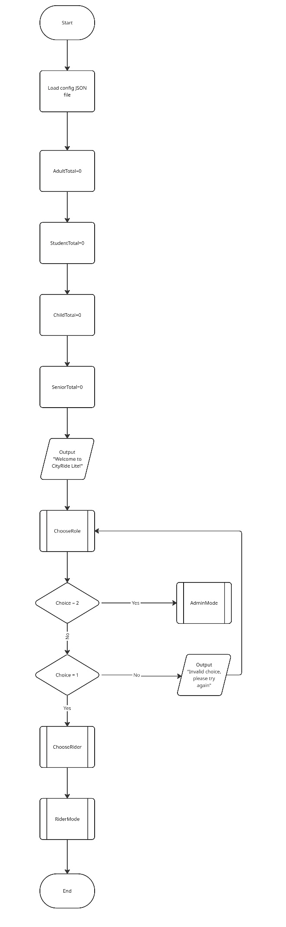
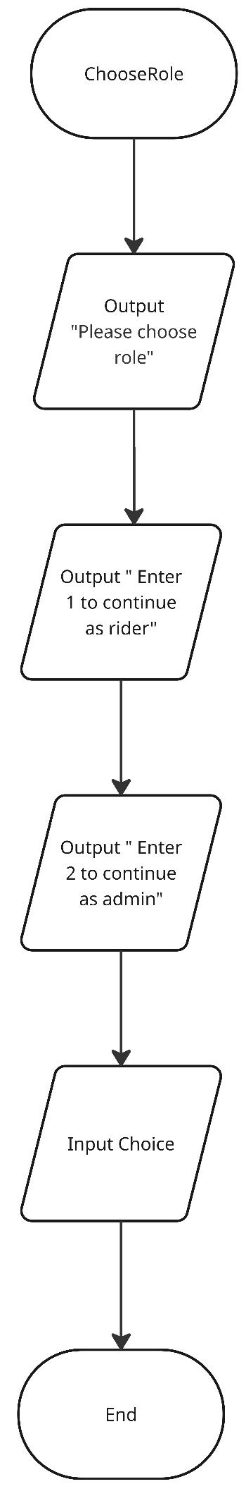
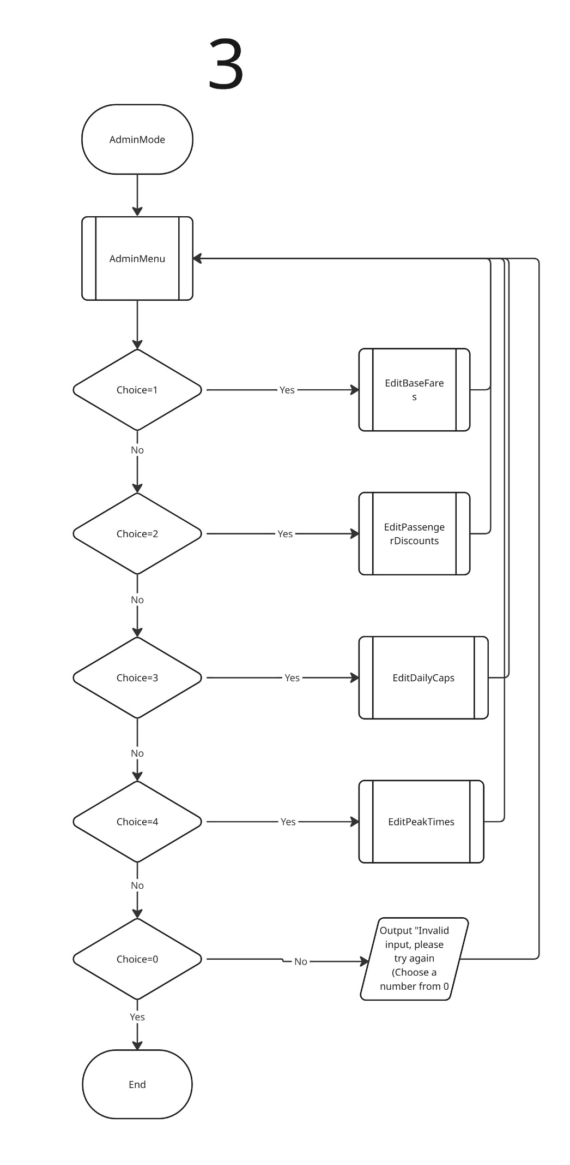
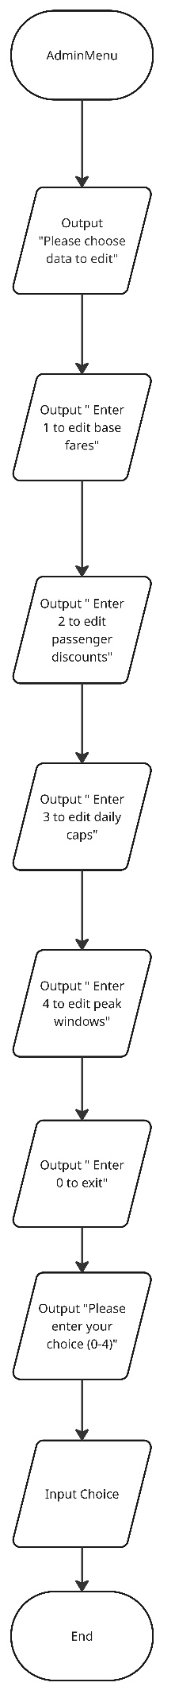
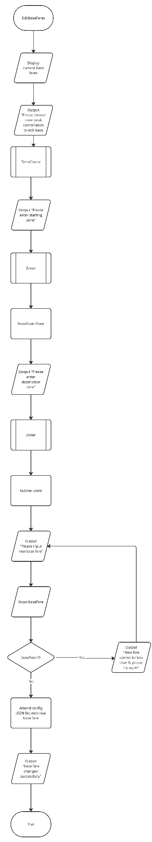
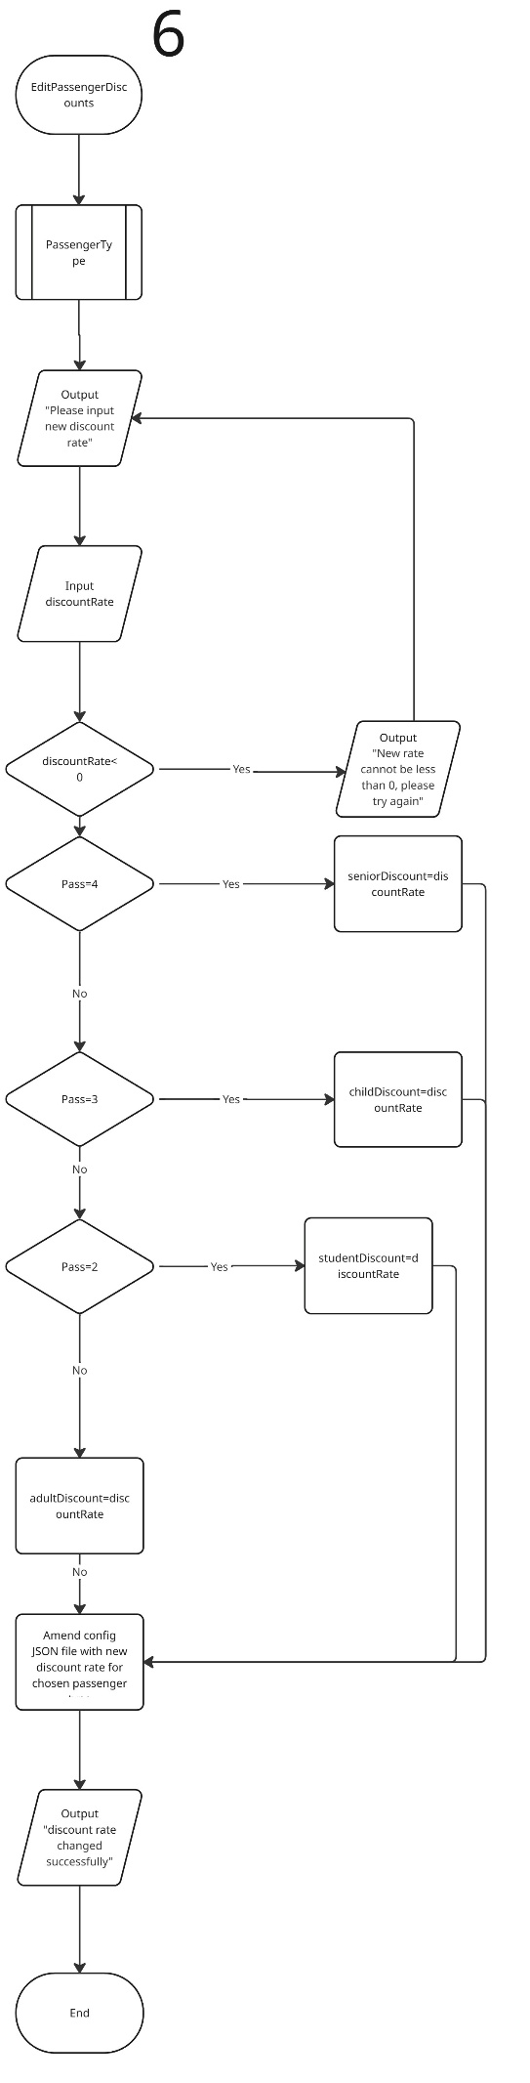
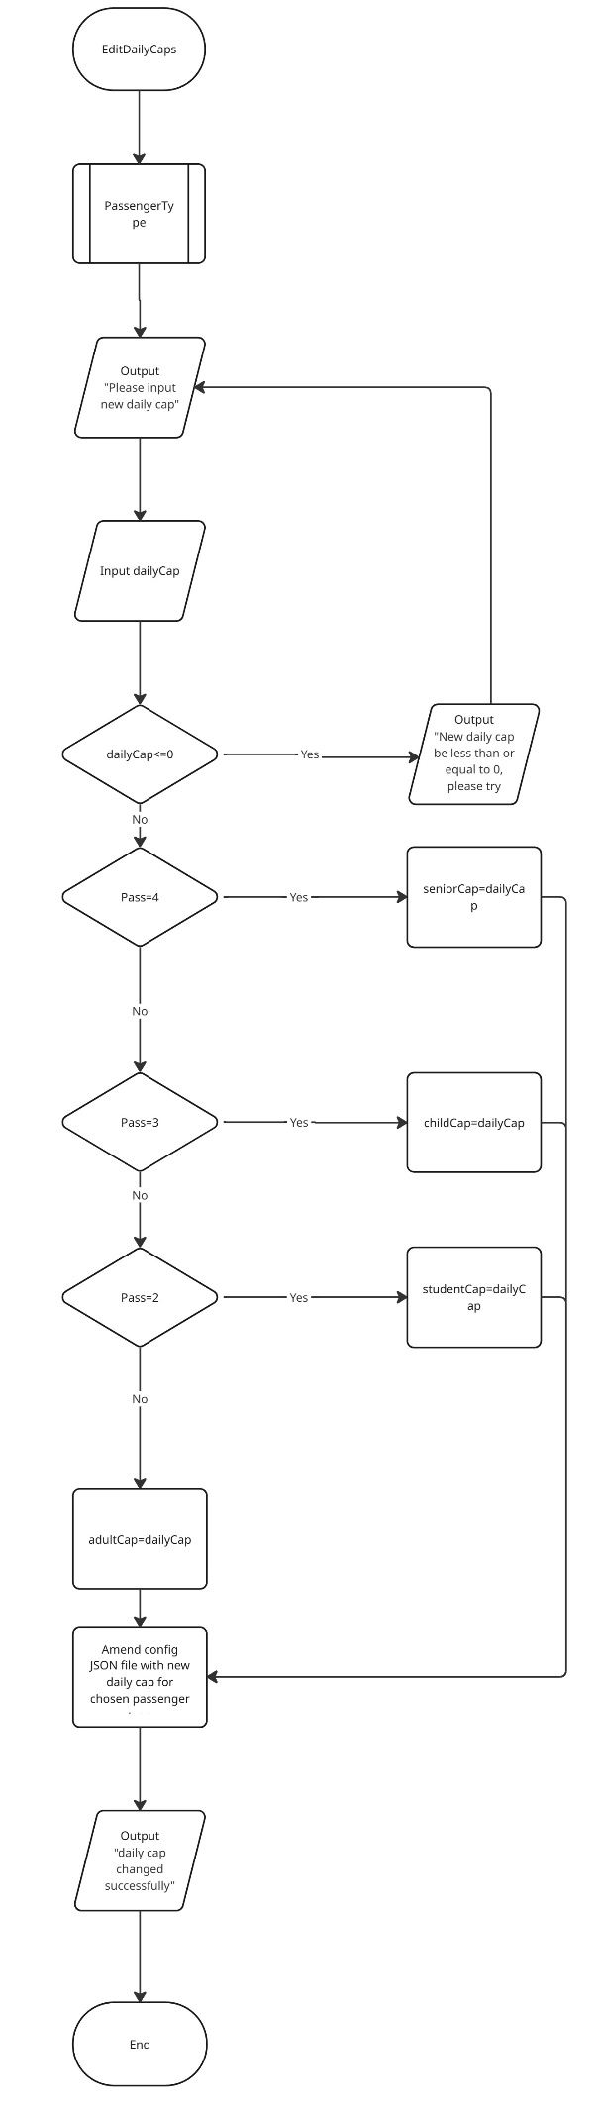
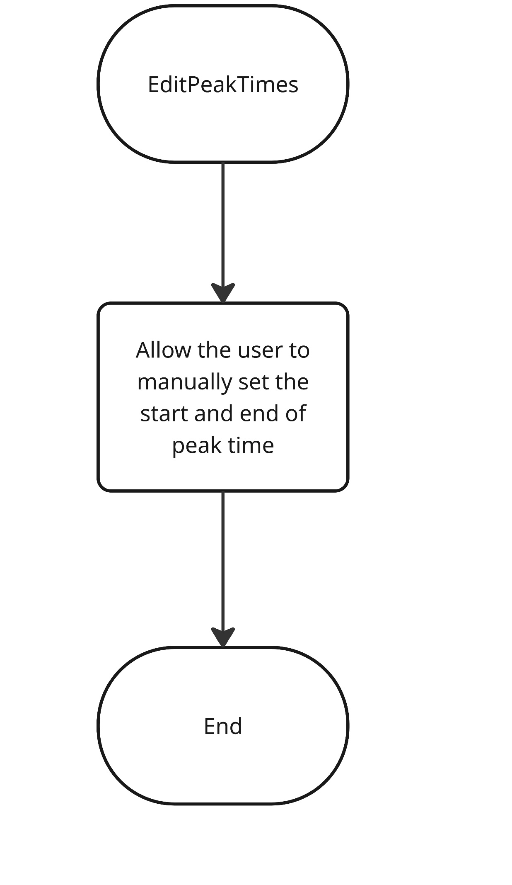
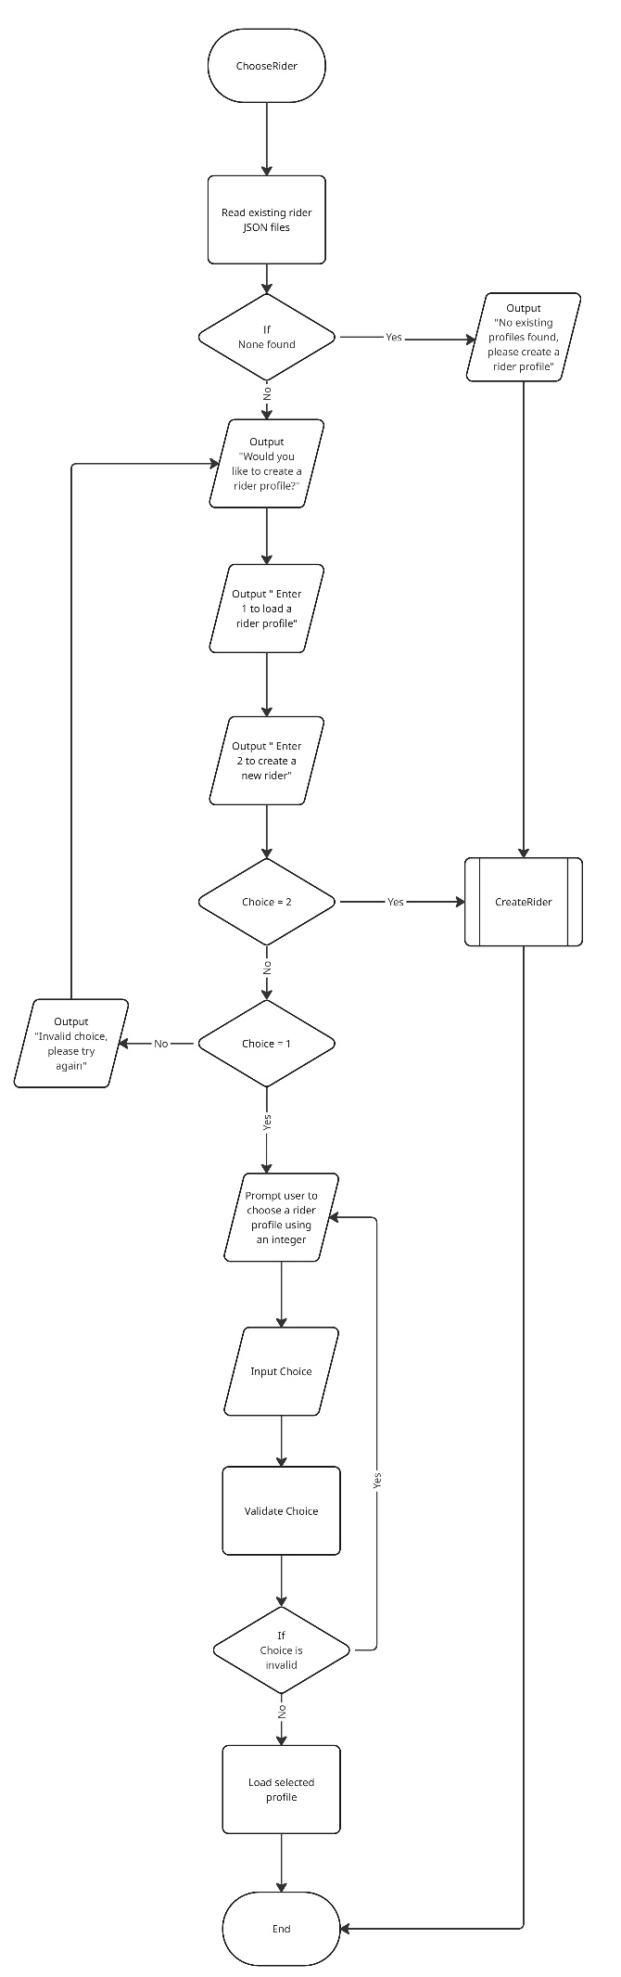
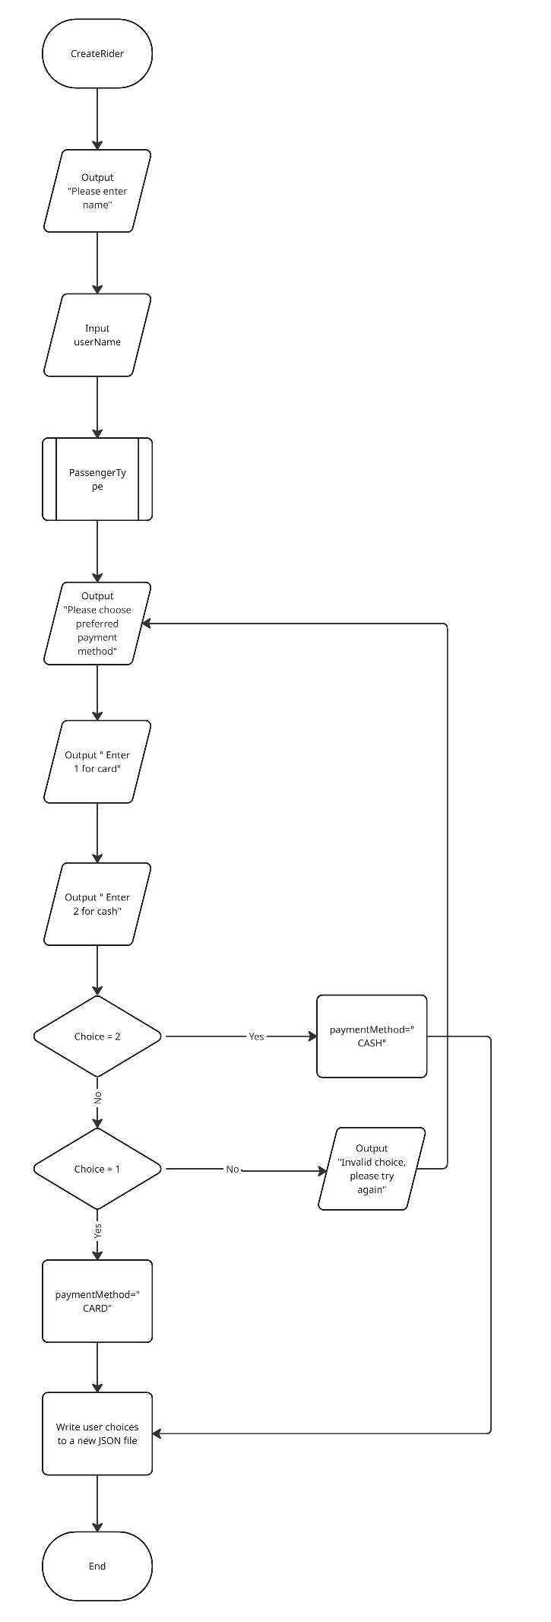
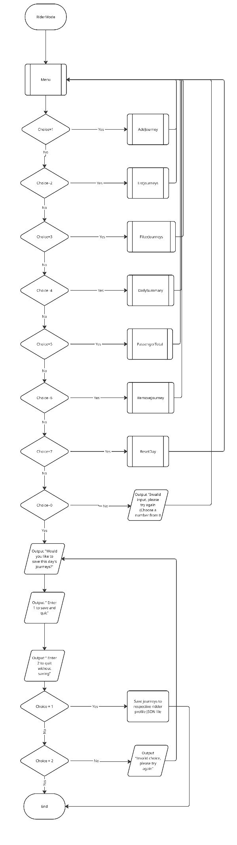
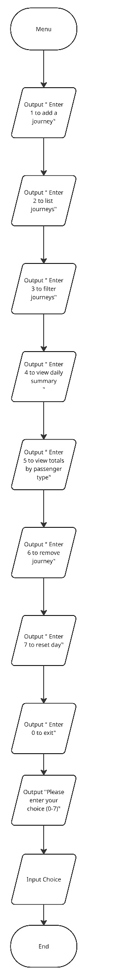
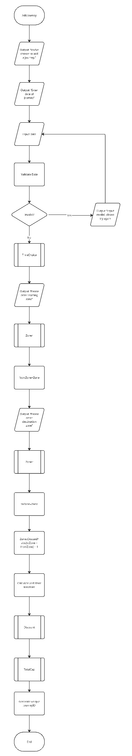
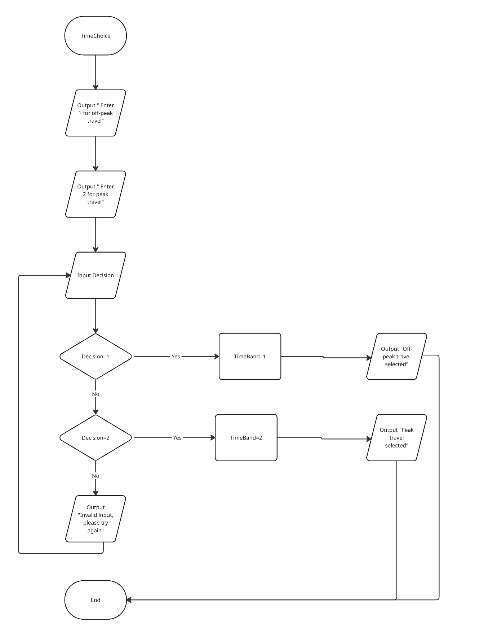
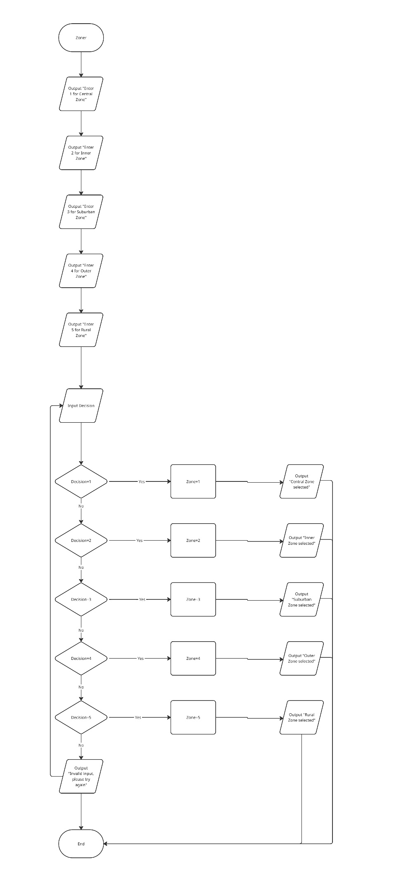
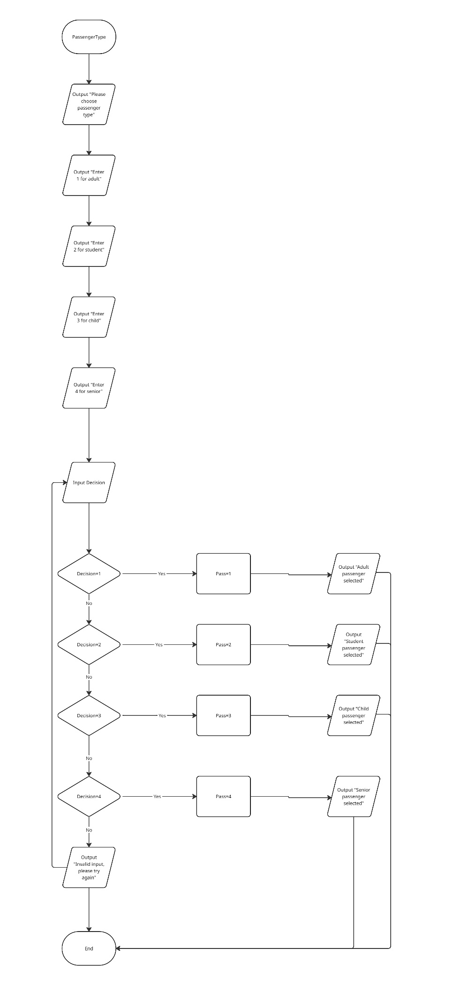
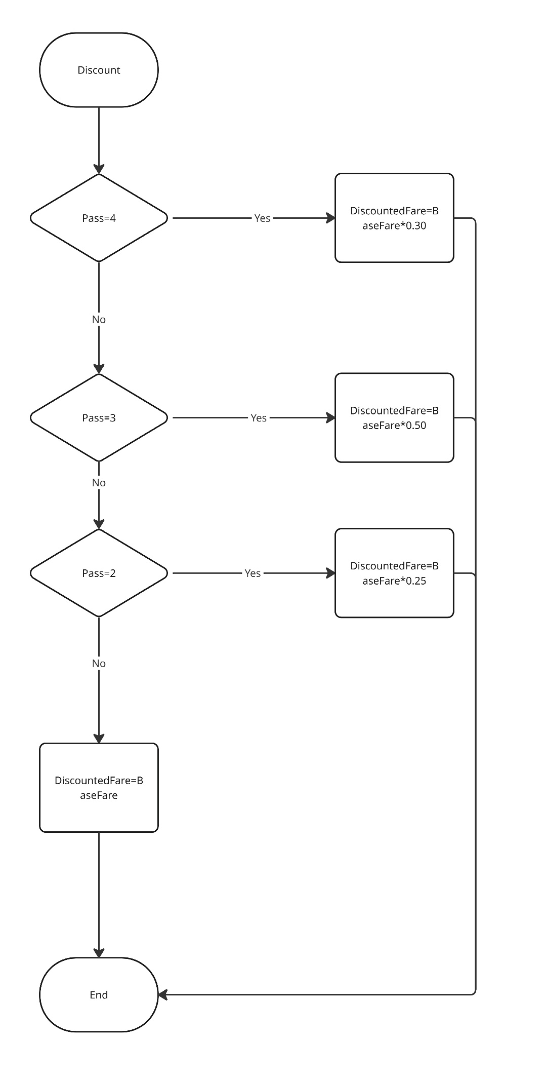
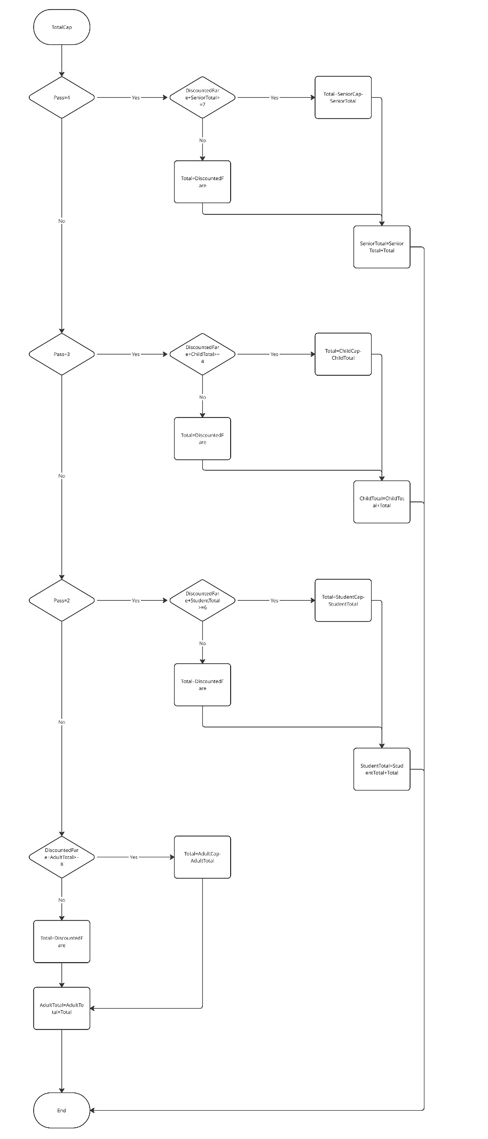
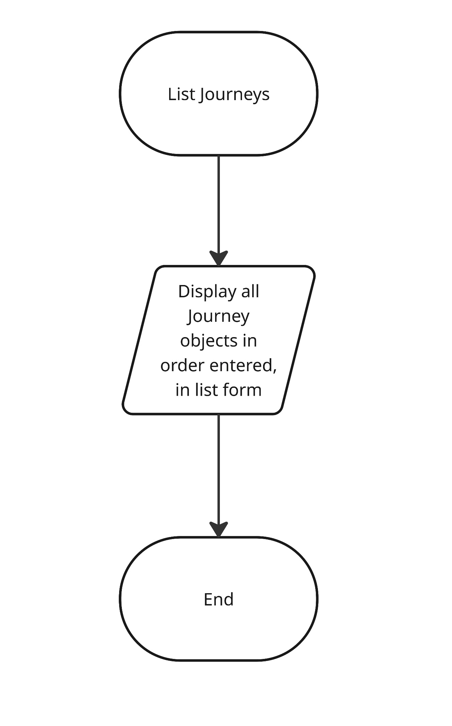
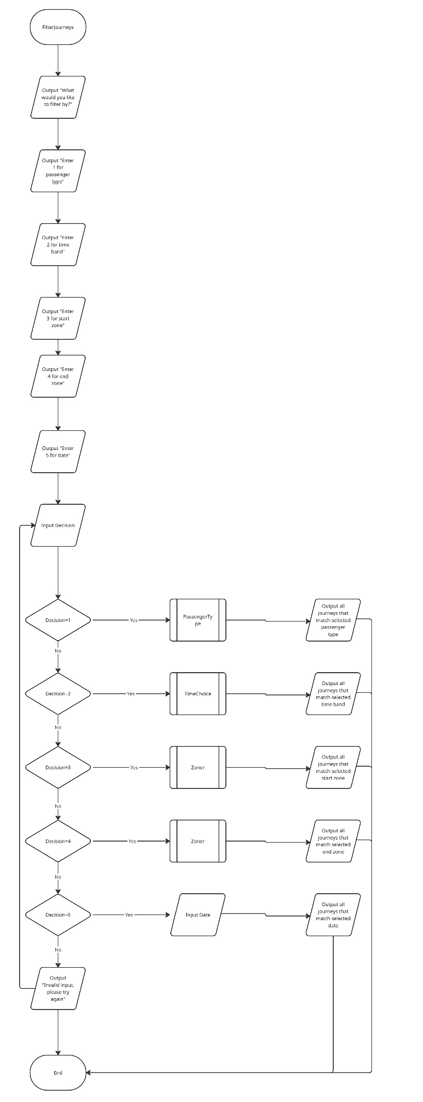
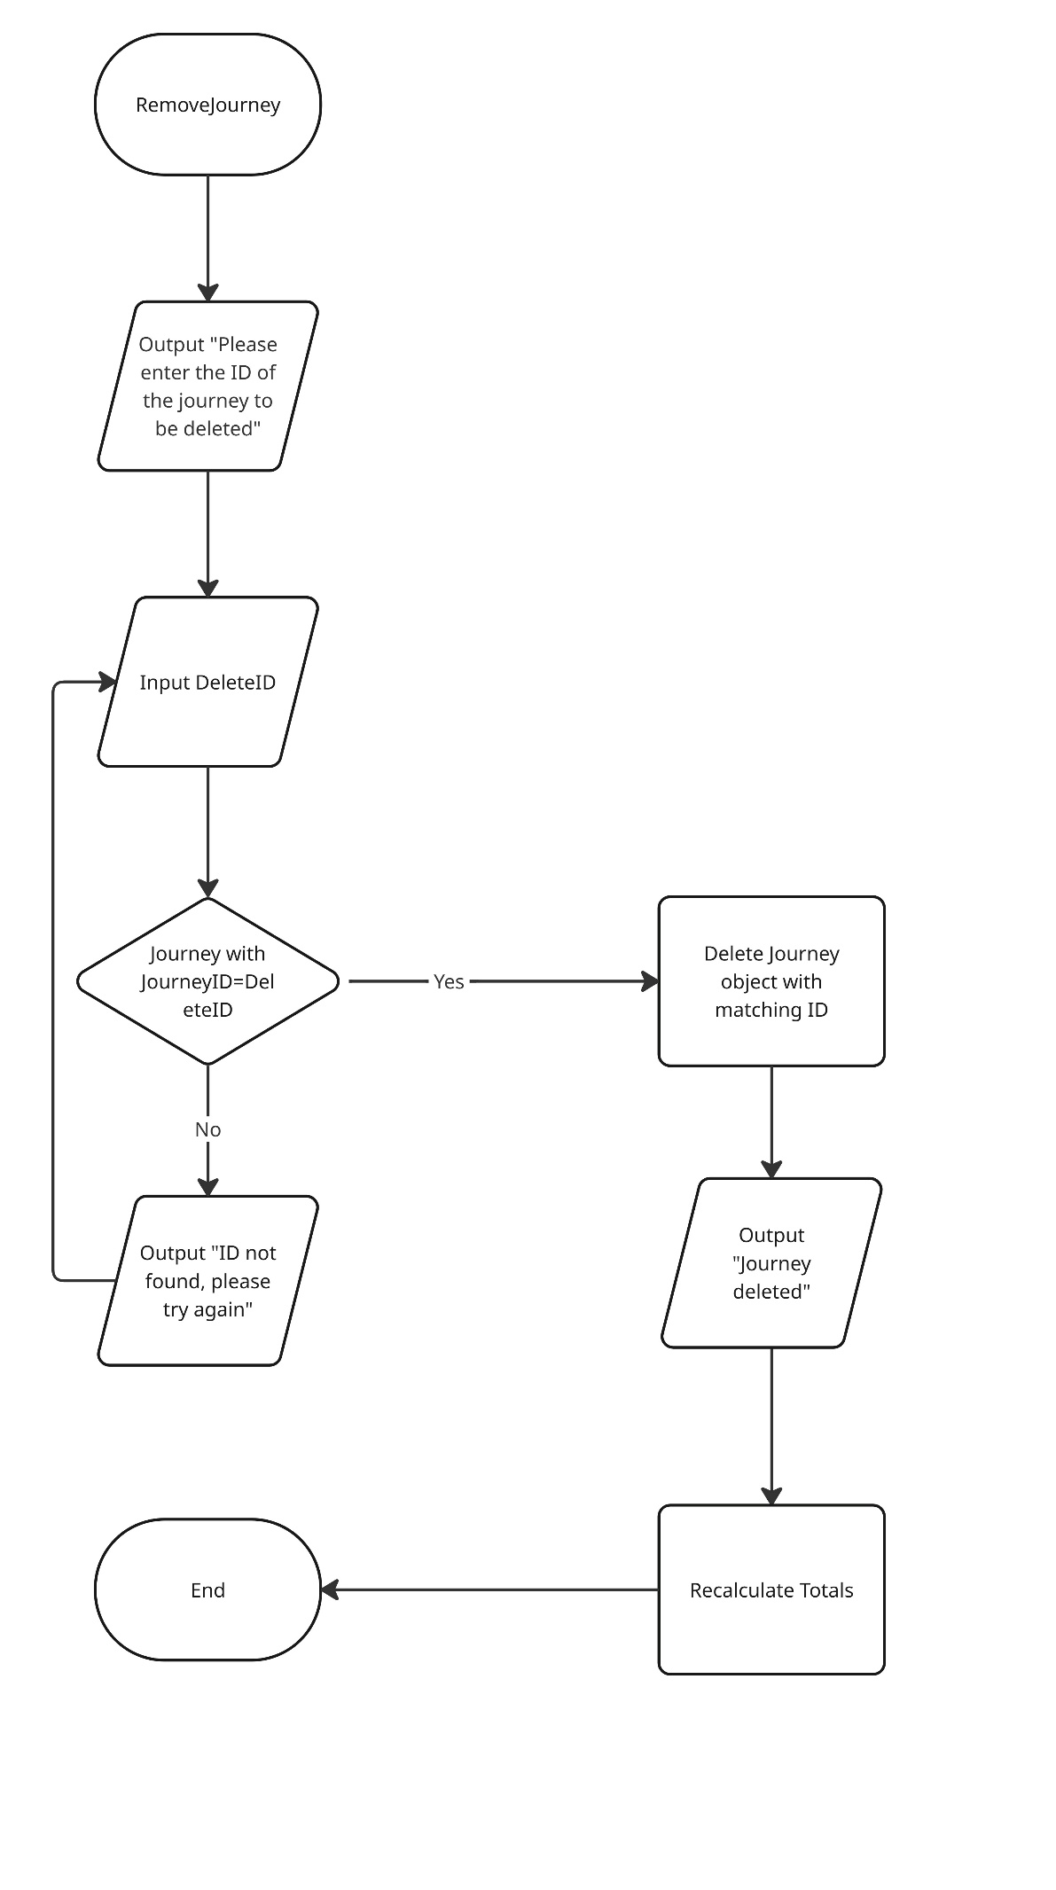
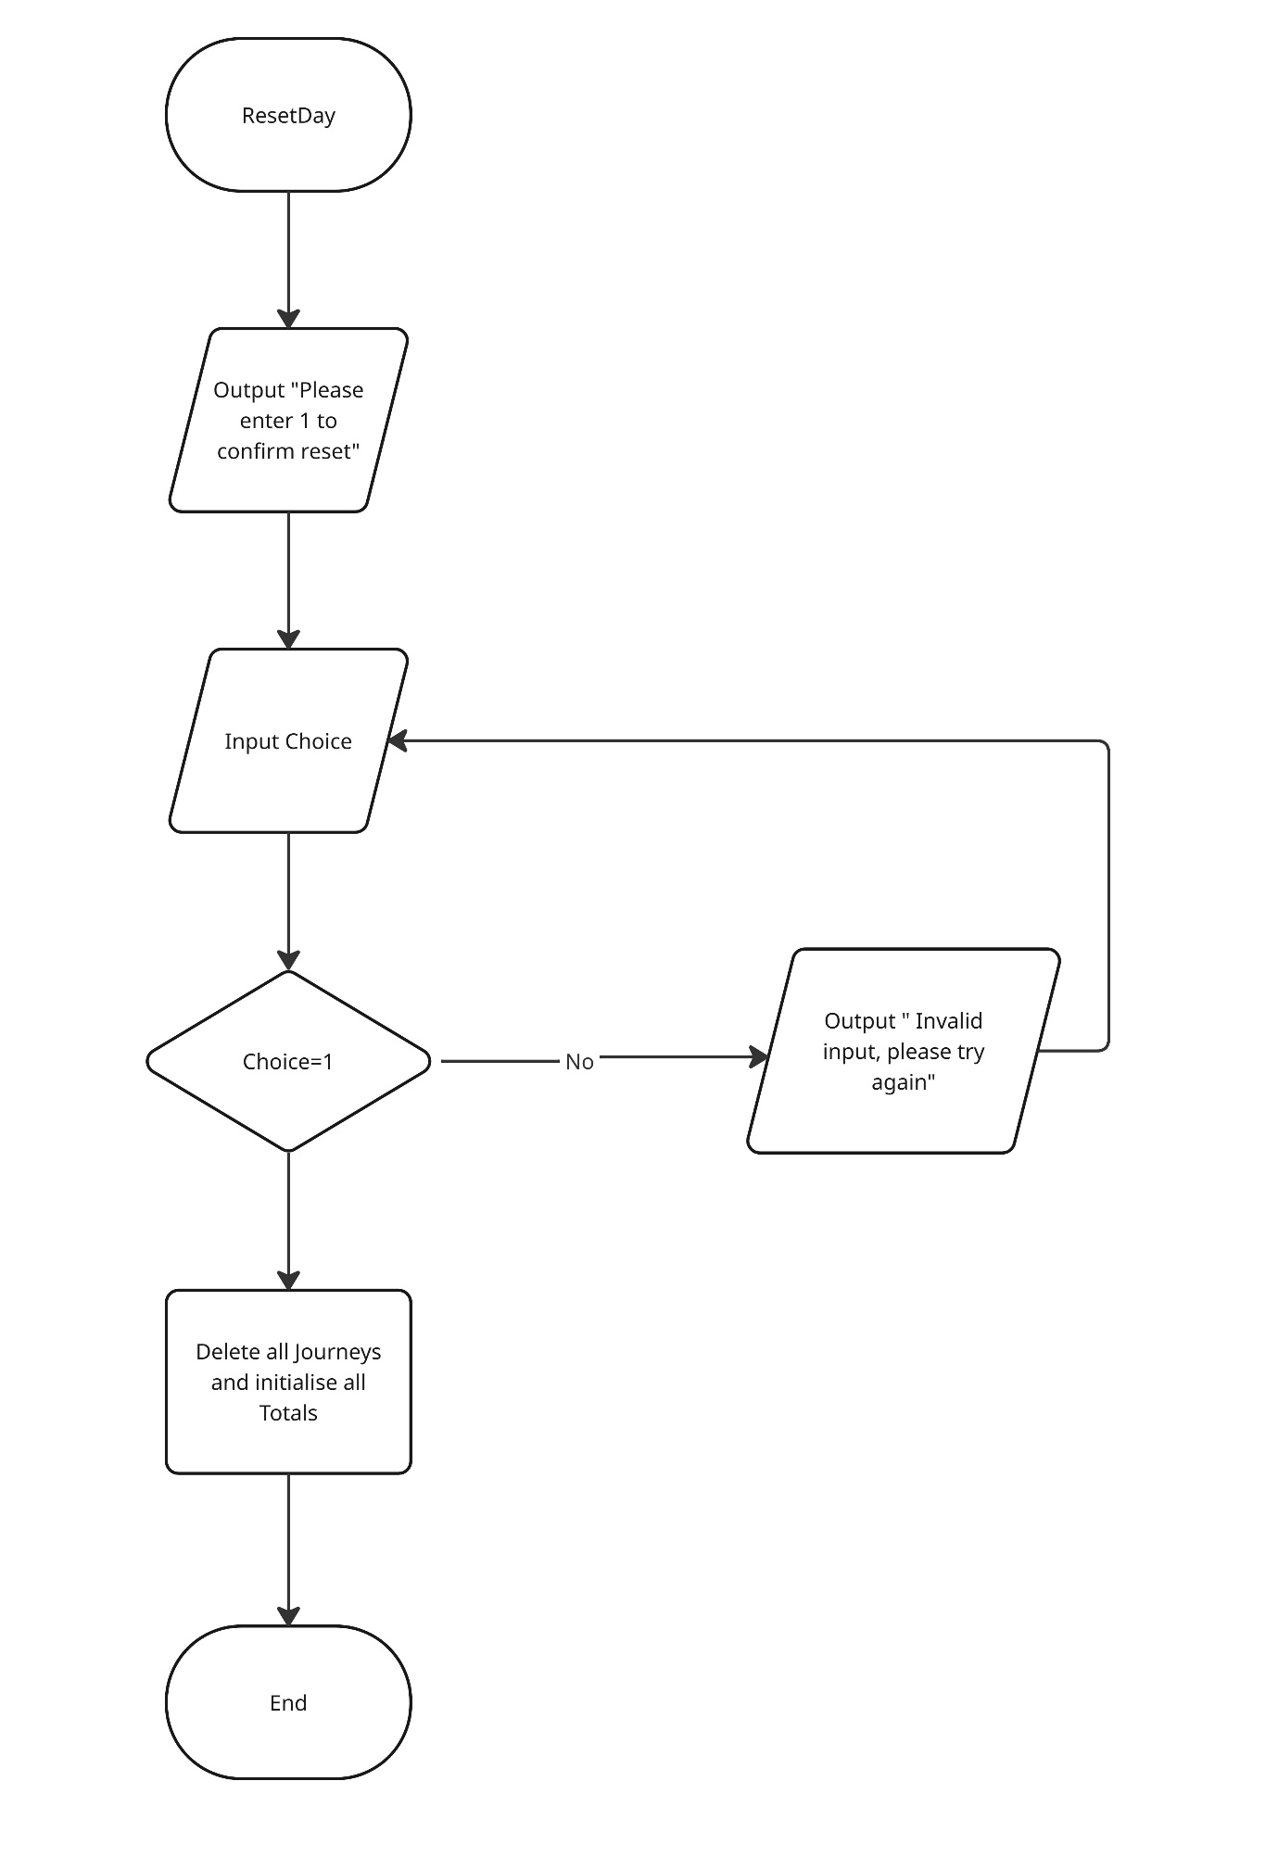
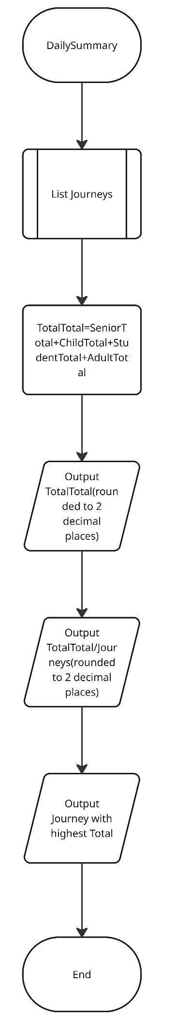
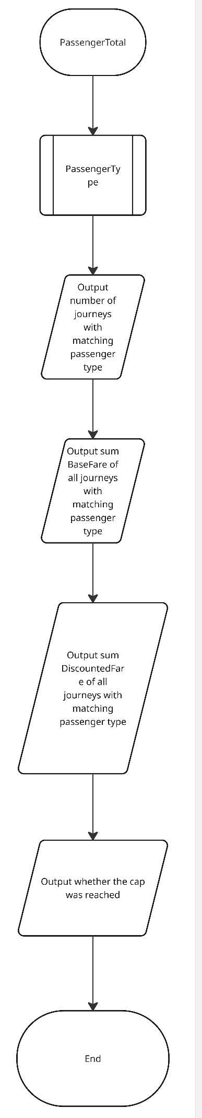

Evaluation
It is believed that the program functions while covering all requirements, including but not limited to: adding journeys, showing all summaries, filtering journeys by specific attributes, deleting a journey, clearing the whole day’s journeys, displaying a daily summary with averages and counters, viewing individual summaries for each passenger type and looping until the user chooses to exist. The program also effectively enforces caps for each passenger type and updates running totals for passengers whenever relevant. Adequate use of functions and functional decomposition is observed, though the code could possibly be further optimised. The use of BigDecimal and UUID represents a much-appreciated boost to accuracy when calculating fares and generating journey IDs.
The program fully supports both admin and rider mode, allowing admins to edit the configuration file that contains passenger caps, discount rates and base fares. The program supports persistence between runs, utilising JSON files in the form of the config and rider files, as well as CSV files, in the form of summary reports and journey list files. Predicates and lambda expressions were successfully implemented, allowing for the removal of large segments of repetitive logic. The class “ConfigFileHandler” could be seen as clunky, and could most likely be improved. Program must restart before editing config file if it was created in the same run.

Code Listing

import java.util.Scanner;
public class CityRide_Lite {
public static void main(String[] args) {
Scanner scanner = new Scanner(System.in);
boolean valid=false;
int choice;
System.out.println("\n Welcome to CityRide Lite");
System.out.println("Enter 1 for Admin Mode (Password Protected)");
System.out.println("Enter 2 for Rider Mode");
System.out.println("Choice: ");
while (valid == false) {
try {
choice = scanner.nextInt();
scanner.nextLine();
switch (choice) {
case 1:
AdminMode.startAdminMode(scanner);
valid = true;
break;
case 2:
RiderMode.startRiderMode(scanner);
valid = true;
break;
default:
System.out.println("Invalid choice, please try again");
break;
}
}
catch(Exception e){
System.out.println("Please enter a valid choice");
scanner.nextLine();
}
}
scanner.close();
}
}
import java.util.Scanner;
public class AdminMode {
public static void startAdminMode(Scanner scanner){
String password="makemesad";
String attempt;
boolean correct=false;
while (!correct){
System.out.println("Enter admin password: ");
attempt=scanner.nextLine();
if (attempt.equals(password)){
System.out.println("Welcome, Admin!");
ConfigFileHandler.start(scanner);
correct=true;
}
else {
System.out.println("Incorrect password, please try again.");
}
}
}
}
import java.math.BigDecimal;
import java.math.RoundingMode;
import java.util.HashMap;
import java.util.Map;
final public class CityRideDataset {
private CityRideDataset() {}
public static final int MIN_ZONE = 1;
public static final int MAX_ZONE = 5;
public static Config config = ConfigFileHandler.loadConfig();
public enum TimeBand {
PEAK,
OFF_PEAK
}
public enum PaymentMethod {
CARD,
CASH
}
public enum PassengerType {
ADULT,
STUDENT,
CHILD,
SENIOR_CITIZEN
}
public static Map<PassengerType, BigDecimal> DISCOUNT_RATE = Map.of(
PassengerType.ADULT, config.getAdultDiscount(),
PassengerType.STUDENT, config.getStudentDiscount(),
PassengerType.CHILD, config.getChildDiscount(),
PassengerType.SENIOR_CITIZEN, config.getSeniorDiscount()
);
public static final Map<PassengerType, BigDecimal> DAILY_CAP = Map.of(
PassengerType.ADULT, config.getAdultCap(),
PassengerType.STUDENT, config.getStudentCap(),
PassengerType.CHILD, config.getChildCap(),
PassengerType.SENIOR_CITIZEN, config.getSeniorCap()
);
public static final Map<String, BigDecimal> BASE_FARE = config.getBASE_FARE();
public static BigDecimal getBaseFare(int fromZone, int toZone, TimeBand timeBand) {
return BASE_FARE.get(key(fromZone, toZone, timeBand));
}
public static String key(int fromZone, int toZone, TimeBand timeBand) {
return fromZone + "-" + toZone + "-" + timeBand.name();
}
}
import java.math.BigDecimal;
import java.math.RoundingMode;
import java.util.HashMap;
import java.util.Iterator;
import java.util.Map;
public class Config {
private BigDecimal adultDiscount;
private BigDecimal studentDiscount;
private BigDecimal childDiscount;
private BigDecimal seniorDiscount;
private BigDecimal adultCap;
private BigDecimal studentCap;
private BigDecimal childCap;
private BigDecimal seniorCap;
private Map<String, BigDecimal> BASE_FARE;
public static String key(int fromZone, int toZone, CityRideDataset.TimeBand timeBand) {
return fromZone + "-" + toZone + "-" + timeBand.name();
}
private static BigDecimal money(String amount) {
return new BigDecimal(amount).setScale(2, RoundingMode.HALF_UP);
}
public static Map<String, BigDecimal> buildBaseFare() {
Map<String, BigDecimal> m = new HashMap<>();
// Peak fares
put(m,1,1, CityRideDataset.TimeBand.PEAK,"2.50"); put(m,1,2, CityRideDataset.TimeBand.PEAK,"3.20");
put(m,1,3, CityRideDataset.TimeBand.PEAK,"3.80"); put(m,1,4, CityRideDataset.TimeBand.PEAK,"4.40");
put(m,1,5, CityRideDataset.TimeBand.PEAK,"5.00");
put(m,2,1, CityRideDataset.TimeBand.PEAK,"3.20"); put(m,2,2, CityRideDataset.TimeBand.PEAK,"2.30");
put(m,2,3, CityRideDataset.TimeBand.PEAK,"3.10"); put(m,2,4, CityRideDataset.TimeBand.PEAK,"3.80");
put(m,2,5, CityRideDataset.TimeBand.PEAK,"4.50");
put(m,3,1, CityRideDataset.TimeBand.PEAK,"3.80"); put(m,3,2, CityRideDataset.TimeBand.PEAK,"3.10");
put(m,3,3, CityRideDataset.TimeBand.PEAK,"2.10"); put(m,3,4, CityRideDataset.TimeBand.PEAK,"3.00");
put(m,3,5, CityRideDataset.TimeBand.PEAK,"3.70");
put(m,4,1, CityRideDataset.TimeBand.PEAK,"4.40"); put(m,4,2, CityRideDataset.TimeBand.PEAK,"3.80");
put(m,4,3, CityRideDataset.TimeBand.PEAK,"3.00"); put(m,4,4, CityRideDataset.TimeBand.PEAK,"2.00");
put(m,4,5, CityRideDataset.TimeBand.PEAK,"2.90");
put(m,5,1, CityRideDataset.TimeBand.PEAK,"5.00"); put(m,5,2, CityRideDataset.TimeBand.PEAK,"4.50");
put(m,5,3, CityRideDataset.TimeBand.PEAK,"3.70"); put(m,5,4, CityRideDataset.TimeBand.PEAK,"2.90");
put(m,5,5, CityRideDataset.TimeBand.PEAK,"1.90");
// Off-peak fares
put(m,1,1, CityRideDataset.TimeBand.OFF_PEAK,"2.00"); put(m,1,2, CityRideDataset.TimeBand.OFF_PEAK,"2.70");
put(m,1,3, CityRideDataset.TimeBand.OFF_PEAK,"3.20"); put(m,1,4, CityRideDataset.TimeBand.OFF_PEAK,"3.70");
put(m,1,5, CityRideDataset.TimeBand.OFF_PEAK,"4.20");
put(m,2,1, CityRideDataset.TimeBand.OFF_PEAK,"2.70"); put(m,2,2, CityRideDataset.TimeBand.OFF_PEAK,"1.90");
put(m,2,3, CityRideDataset.TimeBand.OFF_PEAK,"2.60"); put(m,2,4, CityRideDataset.TimeBand.OFF_PEAK,"3.20");
put(m,2,5, CityRideDataset.TimeBand.OFF_PEAK,"3.80");
put(m,3,1, CityRideDataset.TimeBand.OFF_PEAK,"3.20"); put(m,3,2, CityRideDataset.TimeBand.OFF_PEAK,"2.60");
put(m,3,3, CityRideDataset.TimeBand.OFF_PEAK,"1.70"); put(m,3,4, CityRideDataset.TimeBand.OFF_PEAK,"2.50");
put(m,3,5, CityRideDataset.TimeBand.OFF_PEAK,"3.10");
put(m,4,1, CityRideDataset.TimeBand.OFF_PEAK,"3.70"); put(m,4,2, CityRideDataset.TimeBand.OFF_PEAK,"3.20");
put(m,4,3, CityRideDataset.TimeBand.OFF_PEAK,"2.50"); put(m,4,4, CityRideDataset.TimeBand.OFF_PEAK,"1.60");
put(m,4,5, CityRideDataset.TimeBand.OFF_PEAK,"2.40");
put(m,5,1, CityRideDataset.TimeBand.OFF_PEAK,"4.20"); put(m,5,2, CityRideDataset.TimeBand.OFF_PEAK,"3.80");
put(m,5,3, CityRideDataset.TimeBand.OFF_PEAK,"3.10"); put(m,5,4, CityRideDataset.TimeBand.OFF_PEAK,"2.40");
put(m,5,5, CityRideDataset.TimeBand.OFF_PEAK,"1.50");
return Map.copyOf(m);
}
private static void put(Map<String, BigDecimal> m, int from, int to, CityRideDataset.TimeBand band, String amount) {
m.put(key(from, to, band), money(amount));
}
public Config(){
adultDiscount=new BigDecimal("0.00");
studentDiscount=new BigDecimal("0.25");
childDiscount=new BigDecimal("0.50");
seniorDiscount=new BigDecimal("0.30");
adultCap=new BigDecimal("8.00");
studentCap=new BigDecimal("6.00");
childCap=new BigDecimal("4.00");
seniorCap=new BigDecimal("7.00");
BASE_FARE = buildBaseFare();
}
public BigDecimal getAdultDiscount(){
return adultDiscount;
}
public BigDecimal getStudentDiscount(){
return studentDiscount;
}
public BigDecimal getChildDiscount(){
return childDiscount;
}
public BigDecimal getSeniorDiscount(){
return seniorDiscount;
}
public BigDecimal getAdultCap() {
return adultCap;
}
public BigDecimal getStudentCap(){
return studentCap;
}
public BigDecimal getChildCap() {
return childCap;
}
public BigDecimal getSeniorCap() {
return seniorCap;
}
public void setAdultDiscount(BigDecimal discount){
this.adultDiscount=discount;
}
public void setStudentDiscount(BigDecimal discount){
this.studentDiscount=discount;
}
public void setChildDiscount(BigDecimal discount){
this.childDiscount=discount;
}
public void setSeniorDiscount(BigDecimal discount){
this.seniorDiscount=discount;
}
public void setAdultCap(BigDecimal cap){
this.adultCap=cap;
}
public void setStudentCap(BigDecimal cap){
this.studentCap=cap;
}
public void setChildCap(BigDecimal cap){
this.childCap=cap;
}
public void setSeniorCap(BigDecimal cap){
this.seniorCap=cap;
}
public Map<String, BigDecimal> getBASE_FARE() {
return BASE_FARE;
}
public void setBASE_FARE(int startZone, int endZone, CityRideDataset.TimeBand time, BigDecimal money) {
BASE_FARE.put(key(startZone,endZone,time),money);
}
//adarshr(2012)
//Function for pretty printing maps
public String toString() {
StringBuilder sb = new StringBuilder();
Iterator<Map.Entry<String, BigDecimal>> iter = BASE_FARE.entrySet().iterator();
while (iter.hasNext()) {
Map.Entry<String, BigDecimal> entry = iter.next();
sb.append(entry.getKey());
sb.append('=').append('"');
sb.append(entry.getValue());
sb.append('"');
if (iter.hasNext()) {
sb.append("\n");
}
}
return sb.toString();
}
}
import com.google.gson.Gson;
import com.google.gson.GsonBuilder;
import com.google.gson.reflect.TypeToken;
import java.io.FileReader;
import java.io.FileWriter;
import java.lang.reflect.Type;
import java.math.BigDecimal;
import java.util.ArrayList;
import java.util.Scanner;
public class ConfigFileHandler {
private static Gson gson = new GsonBuilder().setPrettyPrinting().create();
private static String filename = "config.json";
private static boolean newFile = false;
private static Config config = loadConfig();
public static Config loadConfig() {
Config loadConfigJson = new Config();
try {
FileReader reader = new FileReader(filename);
Type configType = new TypeToken<Config>() {
}.getType();
loadConfigJson = gson.fromJson(reader, configType);
} catch (Exception e) {
System.err.println("No config file found. Starting with safe default values.");
System.err.println("Creating config file...");
ConfigFileHandler.newFile =true;
saveConfig(loadConfigJson);
}
return loadConfigJson;
}
public static void saveConfig(Config config) {
try {
FileWriter writer = new FileWriter(filename);
gson.toJson(config, writer);
writer.close();
System.out.println("Config file saved");
} catch (Exception e) {
System.err.println("Error saving config.");
e.printStackTrace();
}
}
public static void editCap(Scanner scanner) {
boolean valid = false;
int choice = 0;
System.out.println("Which cap would you like to edit?");
System.out.println("Enter 1 for Adult Cap");
System.out.println("Enter 2 for Student Cap");
System.out.println("Enter 3 for Child Cap");
System.out.println("Enter 4 for Senior Cap");
System.out.println("Choice: ");
while (valid == false) {
try {
choice = scanner.nextInt();
scanner.nextLine();
switch (choice) {
case 1:
config.setAdultCap(getMoney(scanner,"Please enter the new Adult cap: "));
valid = true;
break;
case 2:
config.setStudentCap(getMoney(scanner,"Please enter the new Student cap: "));
valid = true;
break;
case 3:
config.setChildCap(getMoney(scanner,"Please enter the new Child cap: "));
valid = true;
break;
case 4:
config.setSeniorCap(getMoney(scanner,"Please enter the new Senior cap: "));
valid = true;
break;
default:
System.out.println("Invalid choice, please try again");
break;
}
} catch (Exception e) {
System.out.println("Please enter a valid choice");
scanner.nextLine();
}
}
}
public static void editDiscount(Scanner scanner) {
boolean valid = false;
int choice = 0;
System.out.println("Which cap would you like to edit?");
System.out.println("Enter 1 for Adult Discount");
System.out.println("Enter 2 for Student Discount");
System.out.println("Enter 3 for Child Discount");
System.out.println("Enter 4 for Senior Discount");
System.out.println("Choice: ");
while (valid == false) {
try {
choice = scanner.nextInt();
scanner.nextLine();
switch (choice) {
case 1:
config.setAdultDiscount(getDiscount(scanner,"Please enter the new Adult discount in decimals (0.50=50% discount!): "));
valid = true;
break;
case 2:
config.setStudentDiscount(getDiscount(scanner,"Please enter the new Student discount in decimals (0.50=50% discount!): "));
valid = true;
break;
case 3:
config.setChildDiscount(getDiscount(scanner,"Please enter the new Child discount in decimals (0.50=50% discount!): "));
valid = true;
break;
case 4:
config.setSeniorDiscount(getDiscount(scanner,"Please enter the new Senior discount in decimals (0.50=50% discount!): "));
valid = true;
break;
default:
System.out.println("Invalid choice, please try again");
break;
}
} catch (Exception e) {
System.out.println("Please enter a valid choice");
scanner.nextLine();
}
}
}
public static int chooseZone(Scanner scanner, String message){
boolean valid=false;
int choice=0;
System.out.println(message);
System.out.println("Enter 1 for Central Zone");
System.out.println("Enter 2 for Inner Zone");
System.out.println("Enter 3 for Suburban Zone");
System.out.println("Enter 4 for Outer Zone");
System.out.println("Enter 5 for Rural Zone");
System.out.println("Choice: ");
while (valid==false) {
try {
choice = scanner.nextInt();
scanner.nextLine();
if (choice >= CityRideDataset.MIN_ZONE && choice <= CityRideDataset.MAX_ZONE) {
valid = true;
} else {
System.out.println("Invalid choice, please try again");
}
}
catch (Exception e){
System.out.println("Please enter a valid choice");
scanner.nextLine();
}
}
return choice;
}
public static CityRideDataset.TimeBand chooseTime(Scanner scanner, String message) {
boolean valid = false;
int choice;
CityRideDataset.TimeBand timeBand= CityRideDataset.TimeBand.PEAK;
System.out.println(message);
System.out.println("Enter 1 for Peak-time travel");
System.out.println("Enter 2 for Off-peak travel");
System.out.println("Choice: ");
while (valid == false) {
try {
choice = scanner.nextInt();
scanner.nextLine();
switch (choice) {
case 1:
timeBand = CityRideDataset.TimeBand.PEAK;
valid = true;
break;
case 2:
timeBand = CityRideDataset.TimeBand.OFF_PEAK;
valid = true;
break;
default:
System.out.println("Invalid choice, please try again");
break;
}
}
catch(Exception e){
System.out.println("Please enter a valid choice");
scanner.nextLine();
}
}
return timeBand;
}
public static void editBaseFare(Scanner scanner){
int startZone=chooseZone(scanner,"Please choose starting zone");
int endZone=chooseZone(scanner, "Please choose destination zone");
CityRideDataset.TimeBand timeBand=chooseTime(scanner,"Please choose timeband");
BigDecimal newFare=getMoney(scanner, "Please enter the new base fare: ");
config.setBASE_FARE(startZone,endZone,timeBand,newFare);
}
public static void editConfig(Scanner scanner) {
boolean valid = false;
int choice = 0;
System.out.println("What would you like to edit?");
System.out.println("Enter 1 for Passenger Caps");
System.out.println("Enter 2 for Passenger Discounts");
System.out.println("Enter 3 for Base Fares");
System.out.println("Choice: ");
while (valid == false) {
try {
choice = scanner.nextInt();
scanner.nextLine();
switch (choice) {
case 1:
editCap(scanner);
valid = true;
break;
case 2:
editDiscount(scanner);
valid = true;
break;
case 3:
editBaseFare(scanner);
valid = true;
break;
default:
System.out.println("Invalid choice, please try again");
break;
}
} catch (Exception e) {
System.out.println("Please enter a valid choice");
scanner.nextLine();
}
}
}
public static void displayConfig(){
System.out.println("\n--- Config List ---");
System.out.println("Adult Cap: " + config.getAdultCap());
System.out.println("Student Cap: " + config.getStudentCap());
System.out.println("Child Cap: " + config.getChildCap());
System.out.println("Senior Cap: " + config.getSeniorCap());
System.out.println("-----------------------------------");
System.out.println("Adult Discount: " + config.getAdultDiscount() + "%");
System.out.println("Student Discount: " + config.getStudentDiscount() + "%");
System.out.println("Child Discount: " + config.getChildDiscount() + "%");
System.out.println("Senior Discount: " + config.getSeniorDiscount() + "%");
System.out.println("-----------------------------------");
System.out.println(config.toString());
}
public static int getMenuChoice(Scanner scanner) {
int choice=0;
boolean valid=false;
while (valid==false){
try {
choice = scanner.nextInt();
scanner.nextLine();
valid=true;
} catch (Exception e) {
System.out.println("Please enter a valid choice");
scanner.nextLine();
}
}
return choice;
}
public static BigDecimal getMoney(Scanner scanner, String message) {
String amount;
BigDecimal money=new BigDecimal("0.00");
boolean valid=false;
System.out.println(message);
while (valid==false){
try {
amount = scanner.nextLine();
money=new BigDecimal(amount);
valid=true;
} catch (Exception e) {
System.out.println("Please enter a valid amount");
}
}
return money;
}
public static BigDecimal getDiscount(Scanner scanner, String message){
BigDecimal discount=getMoney(scanner,message);
boolean valid=false;
while (!valid) {
if (discount.compareTo(BigDecimal.ZERO) < 0 || discount.compareTo(BigDecimal.ONE) > 0) {
System.out.println("Please enter a valid amount");
discount=getMoney(scanner,message);
}
else {
valid=true;
}
}
return discount;
}
public static void showMenu(){
System.out.println("\n ---Admin Menu--- ");
System.out.println("1. View config file");
System.out.println("2. Edit config file");
System.out.println("3. Exit");
System.out.println("Enter a choice");
}
public static void start(Scanner scanner) {
if (!newFile) {
int choice;
do {
showMenu();
choice = getMenuChoice(scanner);
switch (choice) {
case 1:
displayConfig();
break;
case 2:
editConfig(scanner);
saveConfig(config);
break;
case 3:
System.out.println("Program Ended!");
break;
default:
System.out.println("Invalid choice. Try again");
}
} while (choice != 3);
}
}
}
import java.math.BigDecimal;
import java.math.RoundingMode;
import java.time.LocalDate;
import java.util.Scanner;
import java.util.UUID;
public class Journey {
private CityRideDataset.TimeBand journeyTime;
private LocalDate journeyDate;
private int startZone;
private int endZone;
private CityRideDataset.PassengerType passenger;
private BigDecimal baseFare;
private BigDecimal discountFare;
private BigDecimal finalFare;
private String journeyID;
public Journey(Scanner scanner){
journeyTime = chooseTime(scanner, "Please choose timeband");
journeyDate =LocalDate.now();
startZone = chooseZone(scanner, "Please choose starting zone");
endZone = chooseZone(scanner, "Please choose destination zone");
passenger = choosePassenger(scanner, "Please choose passenger type");
baseFare= CityRideDataset.getBaseFare(startZone,endZone,journeyTime);
discountFare=discount();
finalFare=finalFare();
journeyID = UUID.randomUUID().toString();
}
public Journey(CityRideDataset.TimeBand journeyTime,LocalDate journeyDate,int startZone,int endZone,CityRideDataset.PassengerType passenger,BigDecimal baseFare,BigDecimal discountFare,BigDecimal finalFare,String journeyID){
this.journeyTime = journeyTime;
this.journeyDate =journeyDate;
this.startZone = startZone;
this.endZone = endZone;
this.passenger = passenger;
this.baseFare= baseFare;
this.discountFare=discountFare;
this.finalFare=finalFare;
this.journeyID = journeyID;
}
public CityRideDataset.TimeBand chooseTime(Scanner scanner, String message) {
boolean valid = false;
int choice;
CityRideDataset.TimeBand timeBand= CityRideDataset.TimeBand.PEAK;
System.out.println(message);
System.out.println("Enter 1 for Peak-time travel");
System.out.println("Enter 2 for Off-peak travel");
System.out.println("Choice: ");
while (valid == false) {
try {
choice = scanner.nextInt();
scanner.nextLine();
switch (choice) {
case 1:
timeBand = CityRideDataset.TimeBand.PEAK;
valid = true;
break;
case 2:
timeBand = CityRideDataset.TimeBand.OFF_PEAK;
valid = true;
break;
default:
System.out.println("Invalid choice, please try again");
break;
}
}
catch(Exception e){
System.out.println("Please enter a valid choice");
scanner.nextLine();
}
}
return timeBand;
}
public int chooseZone(Scanner scanner, String message){
boolean valid=false;
int choice=0;
System.out.println(message);
System.out.println("Enter 1 for Central Zone");
System.out.println("Enter 2 for Inner Zone");
System.out.println("Enter 3 for Suburban Zone");
System.out.println("Enter 4 for Outer Zone");
System.out.println("Enter 5 for Rural Zone");
System.out.println("Choice: ");
while (valid==false) {
try {
choice = scanner.nextInt();
scanner.nextLine();
if (choice >= CityRideDataset.MIN_ZONE && choice <= CityRideDataset.MAX_ZONE) {
valid = true;
} else {
System.out.println("Invalid choice, please try again");
}
}
catch (Exception e){
System.out.println("Please enter a valid choice");
scanner.nextLine();
}
}
return choice;
}
public CityRideDataset.PassengerType choosePassenger(Scanner scanner, String message){
boolean valid=false;
int choice;
CityRideDataset.PassengerType passenger = CityRideDataset.PassengerType.ADULT;
System.out.println(message);
System.out.println("Enter 1 for Adult passenger");
System.out.println("Enter 2 for Student passenger");
System.out.println("Enter 3 for Child passenger");
System.out.println("Enter 4 for Senior passenger");
System.out.println("Choice: ");
while (valid==false) {
try {
choice = scanner.nextInt();
scanner.nextLine();
switch (choice) {
case 1:
passenger = CityRideDataset.PassengerType.ADULT;
valid = true;
break;
case 2:
passenger = CityRideDataset.PassengerType.STUDENT;
valid = true;
break;
case 3:
passenger = CityRideDataset.PassengerType.CHILD;
valid = true;
break;
case 4:
passenger = CityRideDataset.PassengerType.SENIOR_CITIZEN;
valid = true;
break;
default:
System.out.println("Invalid choice, please try again");
}
}
catch (Exception e){
System.out.println("Please enter a valid choice");
scanner.nextLine();
}
}
return passenger;
}
public BigDecimal discount(){
BigDecimal discountfare;
discountfare=(baseFare.subtract(CityRideDataset.DISCOUNT_RATE.get(passenger).multiply(baseFare))).setScale(2, RoundingMode.HALF_UP);
return discountfare;
}
public BigDecimal finalFare() {
if (((discountFare.add(JourneyList.PASSENGER_TOTAL.get(getPassenger()))).compareTo(CityRideDataset.DAILY_CAP.get(getPassenger()))) >= 0) {
finalFare = (CityRideDataset.DAILY_CAP.get(getPassenger())).subtract(JourneyList.PASSENGER_TOTAL.get(getPassenger()));
}
else{
finalFare=discountFare;
}
JourneyList.PASSENGER_TOTAL.put(passenger, JourneyList.PASSENGER_TOTAL.get(passenger).add(finalFare));
return finalFare;
}
public CityRideDataset.TimeBand getJourneyTime(){
return journeyTime;
}
public LocalDate getJourneyDate(){
return journeyDate;
}
public int getStartZone(){
return startZone;
} public int getEndZone(){
return endZone;
}
public CityRideDataset.PassengerType getPassenger(){
return passenger;
}
public BigDecimal getBaseFare(){
return baseFare;
}
public BigDecimal getDiscountFare(){
return discountFare;
}
public BigDecimal getFinalFare(){
return finalFare;
}
public String getJourneyID(){
return journeyID;
}
public void setJourneyTime(Scanner scanner){
this.journeyTime = chooseTime(scanner, "Please choose travel time" );
}
public void setJourneyDate(){
this.journeyDate =LocalDate.now();
}
public void setStartZone(Scanner scanner){
this.startZone =chooseZone(scanner,"Please choose starting zone" );
}
public void setEndZone(Scanner scanner){
this.endZone =chooseZone(scanner,"Please choose starting zone");
}
public void setPassenger(Scanner scanner){
this.passenger =choosePassenger(scanner, "Please choose passenger type");
}
public void setBaseFare(){
this.baseFare = CityRideDataset.getBaseFare(startZone, endZone, journeyTime);
}
public void setDiscountFare(){
this.discountFare = discount();
}
public void setFinalFare(){
this.finalFare = finalFare();
}
public String toCSV(){
return journeyDate + ","+ journeyTime + "," + startZone + "," + endZone + "," + passenger + "," + baseFare + "," + discountFare + "," + finalFare + "," + journeyID;
}
public void displayDetails(){
System.out.println("[" + journeyDate + "] Time: "+ journeyTime + "| Starting Zone: " + startZone + "| Destination Zone: " + endZone + "| Zones Crossed: " + (Math.abs(endZone - startZone) + 1) + "| Passenger Type: " + passenger + " | Base Fare: £" + baseFare + "| Discount Applied: "+ CityRideDataset.DISCOUNT_RATE.get(passenger).movePointRight(2).setScale(0, RoundingMode.HALF_UP) + "% | Discounted Fare: £" + discountFare + "| Final Fare: £" + finalFare + "| Journey ID: " + journeyID);
}
}
import java.io.*;
import java.math.BigDecimal;
import java.time.LocalDate;
import java.util.ArrayList;
import java.util.List;
import java.util.Scanner;
public class JourneyFileHandler {
public static void writeJourneysToFile(String fileName, List<Journey> journeys) {
try {
PrintWriter writer = new PrintWriter(new FileWriter(fileName+".csv"));
writer.println("Journey Date,Journey Time,Start Zone,End Zone,Passenger Type,Base Fare,Discounted Fare,Final Fare,Journey ID");
for(Journey journey:journeys){
writer.println(journey.toCSV());
}
writer.close();
System.out.println("Journey data successfully written to file:");
}
catch(IOException e){
System.out.println("Error writing to file!");
}
}
public static List<Journey> readRidersFromFile(String fileName) {
List<Journey> journeys = new ArrayList<>();
try{
int journeyCount=0;
File file=new File(fileName+".csv");
Scanner scanner =new Scanner(file);
if (scanner.hasNextLine()) {
scanner.nextLine();
}
while(scanner.hasNextLine()){
String line = scanner.nextLine();
String[] data = line.split(",");
LocalDate date = LocalDate.parse(data[0]);
CityRideDataset.TimeBand time = CityRideDataset.TimeBand.valueOf(data[1]);
int startZone = Integer.parseInt(data[2]);
int endZone = Integer.parseInt(data[3]);
CityRideDataset.PassengerType passenger = CityRideDataset.PassengerType.valueOf(data[4]);
BigDecimal baseFare = new BigDecimal(data[5]);
BigDecimal discountFare = new BigDecimal(data[6]);
BigDecimal finalFare = new BigDecimal(data[7]);
String ID = data[8];
Journey journey = new Journey(time,date,startZone,endZone,passenger,baseFare,discountFare,finalFare,ID );
journeys.add(journey);
journeyCount=journeyCount+1;
}
System.out.println(journeyCount +" previous journey(s) found.");
}
catch(FileNotFoundException e){
System.out.println("No previous journeys found.");
}
catch(NumberFormatException e){
System.out.println("Error: Invalid number in file!");
}
return journeys;
}
}
import java.time.LocalDate;
import java.util.Scanner;
import java.util.List;
import java.util.function.Predicate;
public class JourneyFilter {
static private void filter (List<Journey> journeyList, Predicate<Journey> condition){
boolean found=false;
for(Journey c : journeyList) {
if (condition.test(c)) {
found=true;
c.displayDetails();
}
}
if (found==false){
System.out.println("No matches found.");
}
}
static private void filterPassenger(Scanner scanner, List<Journey> journeyList){
boolean valid = false;
int choice;
System.out.println("Please choose passenger to search for:");
System.out.println("1. Adult");
System.out.println("2. Student");
System.out.println("3. Child");
System.out.println("4. Senior");
System.out.println("Please enter choice (1-4): ");
while (valid==false) {
try {
choice = scanner.nextInt();
scanner.nextLine();
switch (choice) {
case 1:
filter(journeyList, c->c.getPassenger()== CityRideDataset.PassengerType.ADULT);
valid = true;
break;
case 2:
filter(journeyList, c->c.getPassenger()== CityRideDataset.PassengerType.STUDENT);
valid = true;
break;
case 3:
filter(journeyList, c->c.getPassenger()== CityRideDataset.PassengerType.CHILD);
valid = true;
break;
case 4:
filter(journeyList, c->c.getPassenger()== CityRideDataset.PassengerType.SENIOR_CITIZEN);
valid = true;
break;
default:
System.out.println("Invalid choice, please try again");
choice = scanner.nextInt();
scanner.nextLine();
}
} catch (Exception e) {
System.out.println("Please enter a valid choice");
scanner.nextLine();
}
}
}
static private void filterTime(Scanner scanner, List<Journey> journeyList){
boolean valid = false;
int choice;
System.out.println("Please choose time-band to search for:");
System.out.println("1. Peak");
System.out.println("2. Off-Peak");
System.out.println("Please enter choice (1-2): ");
while (valid==false) {
try {
choice = scanner.nextInt();
scanner.nextLine();
switch (choice) {
case 1:
filter(journeyList, c->c.getJourneyTime()== CityRideDataset.TimeBand.PEAK);
valid = true;
break;
case 2:
filter(journeyList, c->c.getJourneyTime()== CityRideDataset.TimeBand.OFF_PEAK);
valid = true;
break;
default:
System.out.println("Invalid choice, please try again");
choice = scanner.nextInt();
scanner.nextLine();
}
} catch (Exception e) {
System.out.println("Please enter a valid choice");
scanner.nextLine();
}
}
}
static private void filterZone(Scanner scanner, List<Journey> journeyList, boolean startZone){
//A boolean "switch" is used here to allow for one function to handle the filtering of both start and end zones
boolean valid = false;
int choice;
boolean found=false;
System.out.println("Please choose zone to search for:");
System.out.println("Enter 1 for Central Zone");
System.out.println("Enter 2 for Inner Zone");
System.out.println("Enter 3 for Suburban Zone");
System.out.println("Enter 4 for Outer Zone");
System.out.println("Enter 5 for Rural Zone");
System.out.println("Choice: ");
while (valid==false) {
try {
choice = scanner.nextInt();
scanner.nextLine();
if (choice>0 && choice<6) {
final int finalChoice = choice;
if (startZone) {
filter(journeyList, c -> c.getStartZone() == finalChoice);
}
else{
filter(journeyList, c -> c.getEndZone() == finalChoice);
}
valid = true;
}
else{
System.out.println("Invalid choice, please try again");
choice = scanner.nextInt();
scanner.nextLine();
}
} catch (Exception e) {
System.out.println("Please enter a valid choice");
scanner.nextLine();
}
}
}
static private void filterDate(Scanner scanner, List<Journey> journeyList) {
System.out.println("Please enter date to search for:");
boolean valid = false;
while (valid == false) {
try {
System.out.println("Please enter day (dd): ");
int day = scanner.nextInt();
scanner.nextLine();
System.out.println("Please enter month (MM): ");
int month = scanner.nextInt();
scanner.nextLine();
System.out.println("Please enter year (yyyy): ");
int year = scanner.nextInt();
scanner.nextLine();
LocalDate date= LocalDate.of(year,month,day);
filter(journeyList, c->c.getJourneyDate().equals(date));
valid = true;
} catch (Exception e) {
System.out.println("Please enter a valid choice");
scanner.nextLine();
}
}
}
static public void filterJourney(Scanner scanner, List<Journey> journeyList){
boolean valid = false;
int choice;
System.out.println("Please choose filter category:");
System.out.println("1. Passenger Type");
System.out.println("2. Time Band");
System.out.println("3. Start Zone");
System.out.println("4. End Zone");
System.out.println("5. Date");
System.out.println("Please enter choice (1-5): ");
while (valid==false) {
try {
choice = scanner.nextInt();
scanner.nextLine();
switch (choice) {
case 1:
filterPassenger(scanner,journeyList);
valid = true;
break;
case 2:
filterTime(scanner,journeyList);
valid = true;
break;
case 3:
filterZone(scanner,journeyList, true);
valid = true;
break;
case 4:
filterZone(scanner,journeyList, false);
valid = true;
break;
case 5:
filterDate(scanner,journeyList);
valid = true;
break;
default:
System.out.println("Invalid choice, please try again");
choice = scanner.nextInt();
scanner.nextLine();
}
} catch (Exception e) {
System.out.println("Please enter a valid choice");
scanner.nextLine();
}
}
}
}
import java.math.BigDecimal;
import java.util.*;
public class JourneyList {
private List<Journey> journeyList = new ArrayList<>();
public static Map<CityRideDataset.PassengerType, BigDecimal> PASSENGER_TOTAL = new HashMap<>();
static {
PASSENGER_TOTAL.put(CityRideDataset.PassengerType.ADULT, new BigDecimal("0.00"));
PASSENGER_TOTAL.put(CityRideDataset.PassengerType.STUDENT, new BigDecimal("0.00"));
PASSENGER_TOTAL.put(CityRideDataset.PassengerType.CHILD, new BigDecimal("0.00"));
PASSENGER_TOTAL.put(CityRideDataset.PassengerType.SENIOR_CITIZEN, new BigDecimal("0.00"));
}
public List<Journey> getJourneyList(){
return journeyList;
}
public void setJourneyList(List<Journey> journeyList){
this.journeyList=journeyList;
}
public void addJourney(Journey c){
journeyList.add(c);
System.out.println("Journey with ID: " + c.getJourneyID() + " has been added.");
}
public Journey findJourneyByID(String ID){
for(Journey c : journeyList){
if(c.getJourneyID().equalsIgnoreCase(ID)){
return c;
}
}
return null;
}
public String deleteJourneyByID(Scanner scanner){
String ID;
System.out.println("Please input ID to delete: ");
ID=scanner.nextLine();
for(Journey c : journeyList){
if(c.getJourneyID().equalsIgnoreCase(ID)){
PASSENGER_TOTAL.put(c.getPassenger(),new BigDecimal(0));
journeyList.remove(c);
for(Journey d : journeyList) {
if(d.getPassenger()==c.getPassenger()) {
d.setFinalFare();
}
}
return "Journey with ID "+ ID +" has been deleted.";
}
}
return "Journey not found";
}
public void showAllJourney(){
if (journeyList.isEmpty()) {
System.out.println("Journey list is empty.");
}
else{
for(Journey c : journeyList) {
c.displayDetails();
}
}
}
public void clearDay(){
if (journeyList.isEmpty()) {
System.out.println("Journey list is empty.");
}
else{
journeyList.clear();
PASSENGER_TOTAL.put(CityRideDataset.PassengerType.ADULT,new BigDecimal(0));
PASSENGER_TOTAL.put(CityRideDataset.PassengerType.STUDENT,new BigDecimal(0));
PASSENGER_TOTAL.put(CityRideDataset.PassengerType.CHILD,new BigDecimal(0));
PASSENGER_TOTAL.put(CityRideDataset.PassengerType.SENIOR_CITIZEN,new BigDecimal(0));
System.out.println("Day cleared successfully.");
}
}
}
import java.math.BigDecimal;
import java.math.RoundingMode;
import java.time.LocalDate;
import java.util.List;
import java.util.Scanner;
public class JourneySummariser {
static public void dailySummary(Scanner scanner, List<Journey> journeyList, String riderName, LocalDate date){
int journeyCount=0;
String highestJourneyID="";
BigDecimal totalCost= new BigDecimal(0);
BigDecimal highestFare= new BigDecimal(0);
BigDecimal averageFare= new BigDecimal(0);
BigDecimal moneySaved= new BigDecimal(0);
int peakCounter=0;
int offPeakCounter=0;
int zone1counter=0;
int zone2counter=0;
int zone3counter=0;
int zone4counter=0;
int zone5counter=0;
boolean capReached=false;
int confirm=0;
if (journeyList.isEmpty()) {
System.out.println("Journey list is empty.");
}
else {
for (Journey c : journeyList) {
journeyCount = journeyCount + 1;
totalCost = totalCost.add(c.getFinalFare());
if (c.getFinalFare().compareTo(highestFare) > 0) {
highestJourneyID = c.getJourneyID();
highestFare = c.getFinalFare();
}
if (c.getJourneyTime()== CityRideDataset.TimeBand.PEAK){
peakCounter+=1;
}
else {
offPeakCounter+=1;
}
if (c.getEndZone()==1 || c.getStartZone()==1){
zone1counter+=1;
}
if (c.getEndZone()==2 || c.getStartZone()==2){
zone2counter+=1;
}
if (c.getEndZone()==3 || c.getStartZone()==3){
zone3counter+=1;
}
if (c.getEndZone()==4 || c.getStartZone()==4){
zone4counter+=1;
}
if (c.getEndZone()==5 || c.getStartZone()==5){
zone5counter+=1;
}
}
moneySaved=moneySaved.add(capSummariser(journeyList, CityRideDataset.PassengerType.ADULT));
moneySaved=moneySaved.add(capSummariser(journeyList, CityRideDataset.PassengerType.STUDENT));
moneySaved=moneySaved.add(capSummariser(journeyList, CityRideDataset.PassengerType.CHILD));
moneySaved=moneySaved.add(capSummariser(journeyList, CityRideDataset.PassengerType.SENIOR_CITIZEN));
averageFare=(totalCost.divide(new BigDecimal(journeyCount))).setScale(2, RoundingMode.HALF_UP);
System.out.println("Total number of journeys: " + journeyCount);
System.out.println("Total cost: " + totalCost);
System.out.println("Average fare : " + averageFare);
System.out.println("Highest Fare: " + highestFare + " with journey ID: " + highestJourneyID);
System.out.println("Number of peak journeys: " + peakCounter);
System.out.println("Number of off-peak journeys: " + offPeakCounter);
System.out.println("Number of journeys to/from Central Zone: " + zone1counter);
System.out.println("Number of journeys to/from Inner Zone: " + zone2counter);
System.out.println("Number of journeys to/from Suburban Zone: " + zone3counter);
System.out.println("Number of journeys to/from Outer Zone: " + zone4counter);
System.out.println("Number of journeys to/from Rural Zone: " + zone5counter);
if ((moneySaved.compareTo(BigDecimal.ZERO))==1){
System.out.println("Cap was reached");
capReached=true;
System.out.println("Money saved due to cap: " + moneySaved);
}
System.out.println("Would you like to export this summary?");
System.out.println("Enter 1 to export");
System.out.println("Enter any other value to decline");
try{
confirm = scanner.nextInt();
scanner.nextLine();
if (confirm==1){
String summaryCSV = riderName + "," + date + "," + journeyCount + "," + totalCost + "," + averageFare + "," + highestFare + "," + highestJourneyID + "," + capReached + "," + moneySaved + "," + peakCounter + "," + offPeakCounter + "," + zone1counter + "," + zone2counter + "," + zone3counter + "," + zone4counter + "," + zone5counter;
SummaryFileHandler.writeSummariesToCSVFile("reports",summaryCSV);
SummaryFileHandler.writeSummariesToTXTFile("reports",riderName,date,journeyCount,highestJourneyID,totalCost,highestFare,averageFare,moneySaved,peakCounter,offPeakCounter,zone1counter,zone2counter,zone3counter,zone4counter,zone5counter,capReached);
}
else{
System.out.println("Export declined");
}
}
catch(Exception e){
System.out.println("Export declined");
}
}
}
static private void passengerSummariser(List<Journey> journeyList, CityRideDataset.PassengerType passenger, String type) {//Shortened method to adhere to guide to good programming.
int journeyCount = 0;
BigDecimal preDiscountSum = new BigDecimal(0);
BigDecimal discountedSum = new BigDecimal(0);
BigDecimal chargedSum = new BigDecimal(0);
if (journeyList.isEmpty()) {
System.out.println("Journey list is empty.");
} else {
boolean found = false;
for (Journey c : journeyList) {
if (c.getPassenger() == passenger) {
journeyCount = journeyCount + 1;
preDiscountSum = preDiscountSum.add(c.getBaseFare());
discountedSum = discountedSum.add(c.getDiscountFare());
chargedSum = chargedSum.add(c.getFinalFare());
found = true;
}
}
if (found == false) {
System.out.println("No " + type.toLowerCase() + " journeys found.");
} else {
System.out.println("| " + type.toUpperCase() + " JOURNEYS |");
System.out.println("No. of " + type + " journeys: " + journeyCount);
System.out.println(type + " journeys total base fare: " + preDiscountSum);
System.out.println(type + " journeys total discounted fare: " + discountedSum);
System.out.println(type + " journeys total charged fare: " + chargedSum);
if ((chargedSum.compareTo(CityRideDataset.DAILY_CAP.get(passenger))) == 0) {
System.out.println("Cap was reached");
} else {
System.out.println("Cap was not reached");
}
}
}
}
static private BigDecimal capSummariser(List<Journey> journeyList, CityRideDataset.PassengerType passenger) {
BigDecimal discountedSum = new BigDecimal(0);
BigDecimal chargedSum = new BigDecimal(0);
BigDecimal moneySaved = new BigDecimal(0);
for (Journey c : journeyList) {
if (c.getPassenger() == passenger) {
discountedSum = discountedSum.add(c.getDiscountFare());
chargedSum = chargedSum.add(c.getFinalFare());
}
}
if ((chargedSum.compareTo(CityRideDataset.DAILY_CAP.get(passenger))) == 0) {
System.out.println("Cap was reached");
moneySaved=discountedSum.subtract(chargedSum);
}
return moneySaved;
}
static public void passengerSummary(List<Journey> journeyList){
if (journeyList.isEmpty()) {
System.out.println("Journey list is empty.");
} else {
passengerSummariser(journeyList, CityRideDataset.PassengerType.ADULT, "Adult");
passengerSummariser(journeyList, CityRideDataset.PassengerType.STUDENT, "Student");
passengerSummariser(journeyList, CityRideDataset.PassengerType.CHILD, "Child");
passengerSummariser(journeyList, CityRideDataset.PassengerType.SENIOR_CITIZEN, "Senior");
}
}
}
import java.util.Scanner;
import java.util.UUID;
public class Rider {
private String name;
private String riderID;
private CityRideDataset.PassengerType passenger;
private CityRideDataset.PaymentMethod paymentMethod;
public Rider() {
}
public Rider(Scanner scanner,String name) {
this.name = name;
this.passenger=choosePassenger(scanner,"Please choose passenger type.");
this.paymentMethod=chooseMethod(scanner,"Please choose default payment method");
riderID = UUID.randomUUID().toString();
}
public CityRideDataset.PassengerType choosePassenger(Scanner scanner, String message){
boolean valid=false;
int choice;
CityRideDataset.PassengerType passenger = CityRideDataset.PassengerType.ADULT;
System.out.println(message);
System.out.println("Enter 1 for Adult passenger");
System.out.println("Enter 2 for Student passenger");
System.out.println("Enter 3 for Child passenger");
System.out.println("Enter 4 for Senior passenger");
System.out.println("Choice: ");
while (valid==false) {
try {
choice = scanner.nextInt();
scanner.nextLine();
switch (choice) {
case 1:
passenger = CityRideDataset.PassengerType.ADULT;
valid = true;
break;
case 2:
passenger = CityRideDataset.PassengerType.STUDENT;
valid = true;
break;
case 3:
passenger = CityRideDataset.PassengerType.CHILD;
valid = true;
break;
case 4:
passenger = CityRideDataset.PassengerType.SENIOR_CITIZEN;
valid = true;
break;
default:
System.out.println("Invalid choice, please try again");
scanner.nextLine();
}
}
catch (Exception e){
System.out.println("Please enter a valid choice");
scanner.nextLine();
}
}
return passenger;
}
public CityRideDataset.PaymentMethod chooseMethod(Scanner scanner, String message) {
boolean valid = false;
int choice;
CityRideDataset.PaymentMethod paymentMethod= CityRideDataset.PaymentMethod.CARD;
System.out.println(message);
System.out.println("Enter 1 for Card");
System.out.println("Enter 2 for Cash");
System.out.println("Choice: ");
while (valid == false) {
try {
choice = scanner.nextInt();
scanner.nextLine();
switch (choice) {
case 1:
paymentMethod = CityRideDataset.PaymentMethod.CARD;
valid = true;
break;
case 2:
paymentMethod = CityRideDataset.PaymentMethod.CASH;
valid = true;
break;
default:
System.out.println("Invalid choice, please try again");
break;
}
}
catch(Exception e){
System.out.println("Please enter a valid choice");
scanner.nextLine();
}
}
return paymentMethod;
}
public CityRideDataset.PassengerType getPassenger(){
return passenger;
}
public void setPassenger(Scanner scanner){
this.passenger =choosePassenger(scanner, "Please choose passenger type");
}
public CityRideDataset.PaymentMethod getMethod(){
return paymentMethod;
}
public void setMethod(Scanner scanner){
this.paymentMethod =chooseMethod(scanner, "Please choose passenger type");
}
public String getName() {
return name;
}
public void setName(String username) {
this.name = username;
}
public String getRiderID() {
return riderID;
}
public void setRiderID(String riderID) {
this.riderID = riderID;
}
}
import com.google.gson.Gson;
import com.google.gson.GsonBuilder;
import com.google.gson.reflect.TypeToken;
import java.io.FileReader;
import java.io.FileWriter;
import java.lang.reflect.Type;
import java.util.ArrayList;
import java.util.Scanner;
public class RiderManager {
private ArrayList<Rider> riders;
private Gson gson;
private String filename;
public RiderManager(){
gson = new GsonBuilder().setPrettyPrinting().create();
filename = "riders.json";
riders = loadRiders();
}
private ArrayList<Rider> loadRiders(){
ArrayList<Rider> loadUsersJson = new ArrayList<>();
try{
FileReader reader = new FileReader(filename);
Type userListType = new TypeToken<ArrayList<Rider>>() {}.getType();
loadUsersJson = gson.fromJson(reader, userListType);
}
catch (Exception e){
System.err.println("No existing riders found. Starting with empty list.");
}
return loadUsersJson;
}
private void saveRiders(){
try{
FileWriter writer = new FileWriter(filename);
gson.toJson(riders,writer);
writer.close();
System.out.println("Users saved to file");
}
catch (Exception e){
System.err.println("Error saving users.");
e.printStackTrace();
}
}
private void addRider(Scanner scanner){
String newRiderName;
System.out.println("Enter rider name: ");
newRiderName=scanner.nextLine();
Rider newRider = new Rider(scanner,newRiderName);
riders.add(newRider);
System.out.println("Rider added successfully");
}
private void displayRiders(){
if(riders.isEmpty()) {
System.out.println("No riders found!");
}
else{
int riderNo=1;
System.out.println("\n--- Rider Profile List ---");
for(Rider rider: riders){
System.out.println("Rider Number: " + riderNo);
System.out.println("Name: " + rider.getName());
System.out.println("ID: " + rider.getRiderID());
System.out.println("Passenger Type: " + rider.getPassenger());
System.out.println("Default Payment method: " + rider.getMethod());
riderNo=riderNo+1;
System.out.println("-----------------------------------");
}
}
}
private Rider selectRider(Scanner scanner){
Rider selectedRider=new Rider();
displayRiders();
if (!(riders.isEmpty())){
boolean valid=false;
do {
System.out.println("Please enter the Rider Number of the profile you'd like to load: ");
int choice = scanner.nextInt();
scanner.nextLine();
if(choice>0 && choice<(riders.size())+1){
selectedRider=riders.get(choice-1);
valid=true;
}
else{
System.out.println("Invalid choice, please try again.");
}
}while (!valid);
}
return selectedRider;
}
private int getMenuChoice(Scanner scanner) {
int choice=0;
boolean valid=false;
while (valid==false){
try {
choice = scanner.nextInt();
scanner.nextLine();
valid=true;
} catch (Exception e) {
System.out.println("Please enter a valid choice");
scanner.nextLine();
}
}
return choice;
}
private void showMenu(){
System.out.println("\n ---User Menu--- ");
System.out.println("1. View all riders");
System.out.println("2. Add a new rider");
System.out.println("3. Select rider profile");
System.out.println("Enter a choice");
}
public Rider start(Scanner scanner){
int choice;
Rider rider=new Rider();
do {
showMenu();
choice=getMenuChoice(scanner);
switch (choice){
case 1:
displayRiders();
break;
case 2:
addRider(scanner);
saveRiders();
break;
case 3:
rider=selectRider(scanner);
break;
default:
System.out.println("Invalid choice. Try again");
break;
}
}while (rider.getName()==null);
return rider;
}
}
import java.time.LocalDate;
import java.util.Scanner;
public class RiderMode {
static public void startRiderMode(Scanner scanner){
RiderManager riderManager = new RiderManager();
Rider rider=riderManager.start(scanner);
JourneyList journeyList = new JourneyList();
journeyList.setJourneyList(JourneyFileHandler.readRidersFromFile(rider.getRiderID()));
int choice=0;
do {
System.out.println("\n CityRide Lite");
System.out.println("1. Add Journey");
System.out.println("2. View All Journeys");
System.out.println("3. Filter Journeys");
System.out.println("4. Delete Journey");
System.out.println("5. Clear Day");
System.out.println("6. View Daily Summary");
System.out.println("7. View Summary by Passenger Type");
System.out.println("8. Exit");
System.out.println("Choice: ");
boolean valid=false;
while (valid==false){
try {
choice = scanner.nextInt();
scanner.nextLine();
valid=true;
} catch (Exception e) {
System.out.println("Please enter a valid choice");
scanner.nextLine();
}
}
switch (choice) {
case 1:
journeyList.addJourney(new Journey(scanner));
break;
case 2:
journeyList.showAllJourney();
break;
case 3:
if (journeyList.getJourneyList().isEmpty()) {
System.out.println("Journey list is empty.");
}
else {
JourneyFilter.filterJourney(scanner, journeyList.getJourneyList());
}
break;
case 4:
int confirm;
System.out.println("Are you sure you'd like to delete a journey?");
System.out.println("Enter 1 to confirm");
try{
confirm = scanner.nextInt();
scanner.nextLine();
if (confirm==1){
System.out.println(journeyList.deleteJourneyByID(scanner));
}
else {
System.out.println("Confirmation declined");
}
}
catch (Exception e){
System.out.println("Confirmation declined");
}
break;
case 5:
System.out.println("Are you sure you'd like to clear all journeys?");
System.out.println("Enter 1 to confirm");
System.out.println("Enter any other value to decline");
try{
confirm = scanner.nextInt();
scanner.nextLine();
if (confirm==1){
journeyList.clearDay();
}
else{
System.out.println("Confirmation declined");
}
}
catch(Exception e){
System.out.println("Confirmation declined");
}
break;
case 6:
JourneySummariser.dailySummary(scanner,journeyList.getJourneyList(), rider.getName(), LocalDate.now());
break;
case 7:
JourneySummariser.passengerSummary(journeyList.getJourneyList());
break;
case 8:
System.out.println("Would you like to save this session's journeys?");
System.out.println("Enter 1 to save");
System.out.println("Enter any other value to decline");
try{
confirm = scanner.nextInt();
scanner.nextLine();
if (confirm==1){
JourneyFileHandler.writeJourneysToFile(rider.getRiderID(),journeyList.getJourneyList());
}
else{
System.out.println("Save declined");
}
}
catch(Exception e){
System.out.println("Save declined");
}
System.out.println("Exiting...");
break;
default:
System.out.println("Invalid choice, please try again");
break;
}
}
while (choice != 8);
}
}
import java.io.FileWriter;
import java.io.IOException;
import java.io.PrintWriter;
import java.io.File;
import java.math.BigDecimal;
import java.time.LocalDate;
public class SummaryFileHandler {
public static void writeSummariesToCSVFile(String fileName,String data) {
try {
if (!(new File(System.getProperty("user.dir")+"/"+fileName+".csv").isFile())) {
PrintWriter writer = new PrintWriter(new FileWriter(fileName+".csv"));
writer.println("Rider Name,Date of Summary,Number of Journeys,Total Cost,Average Cost Per Journey,Highest Fare,Most Expensive Journey,Cap Reached?,Savings Due to Cap,Number of peak journeys,Number of off-peak journeys,Number of journeys to/from Central Zone,Number of journeys to/from Inner Zone,Number of journeys to/from Suburban Zone,Number of journeys to/from Outer Zone,Number of journeys to/from Rural Zone");
writer.close();
}
PrintWriter writer = new PrintWriter(new FileWriter(fileName+".csv",true));
writer.println(data);
writer.close();
System.out.println("Journey data successfully written to file:");
}
catch(IOException e){
System.out.println("Error writing to file!");
}
}
public static void writeSummariesToTXTFile(String fileName, String riderName, LocalDate date, int journeyCount, String highestJourneyID, BigDecimal totalCost, BigDecimal highestFare, BigDecimal averageFare, BigDecimal moneySaved, int peakCounter, int offPeakCounter, int zone1counter, int zone2counter, int zone3counter, int zone4counter, int zone5counter, boolean capReached) {
try {
PrintWriter writer = new PrintWriter(new FileWriter(fileName+".txt",true));
writer.println("-----------------------------------------------------------------------------------");
writer.println("Rider Name: " + riderName);
writer.println("Summary Date: " + date);
writer.println("Total number of journeys: " + journeyCount);
writer.println("Total cost: " + totalCost);
writer.println("Average fare : " + averageFare);
writer.println("Highest Fare: " + highestFare + " with journey ID: " + highestJourneyID);
writer.println("Number of peak journeys: " + peakCounter);
writer.println("Number of off-peak journeys: " + offPeakCounter);
writer.println("Number of journeys to/from Central Zone: " + zone1counter);
writer.println("Number of journeys to/from Inner Zone: " + zone2counter);
writer.println("Number of journeys to/from Suburban Zone: " + zone3counter);
writer.println("Number of journeys to/from Outer Zone: " + zone4counter);
writer.println("Number of journeys to/from Rural Zone: " + zone5counter);
if (capReached){
System.out.println("Cap was reached");
System.out.println("Money saved due to cap: " + moneySaved);
}
writer.close();
System.out.println("Journey data successfully written to file:");
}
catch(IOException e){
System.out.println("Error writing to file!");
}
}
}

References

adarshr (2012). Pretty-print a Map in Java. Stack Overflow [online]. Retrieved from: https://stackoverflow.com/questions/10120273/pretty-print-a-map-in-java [Accessed 20 April 2026]

Appendices

Milestone 2 has not reached completion yet_EEC has been approved.

Milestone 1

Purpose of the Program

Is to act as a public transport companion travel app that allows the user to keep track of their daily travels, allowing them to save the details of each individual journey, such as the starting zone, destination zone, whether the trip is during peak or off-peak times and the passenger type. The program shall calculate the base fare for the journey based on this information using a dataset (which is editable by administrators), before applying any valid discounts or caps. The program shall allow the user to log in as a rider by either creating a new profile (which shall capture the rider's name, passenger type and default payment option) or loading an existing profile. While logged into a rider profile, journeys shall be saved to that particular profile in JSON format Alternatively, the user shall be able to log into a password protected administrator mode which will allow them to view and edit fare rules, discounts, daily caps, and peak time windows. All changes shall be validated before being saved and enforced.

Core program functionality
- Support multiple roles
  - Allow the user to log in using a rider profile, loading all previous journeys made by that profile.
  - Allow the user to create a new rider profile, capturing and validating their name, passenger type, and default payment method.
  - Allow the user to log into a password-protected administartor mode, allowing them to edit the confdiguration file for the system, including fare rules, discounts, daily caps, and peak time windows. All changes shall be validated before being saved and enforced.
- Load config file
  - Load configuration data from a pre-existing JSON config file.
  - If the config file is missing, the system shall use safe values provided through a default dataset
- Manage journeys
  - Store multiple journeys, each with its own details (date, zones, passenger type, time band) as well as calculate the total.
  - Assign a unique ID to each journey.
  - Display summary (exported as a CSV file, and a text report) which includes:
    - Number of journeys
    - Total cost
    - Average cost per journey
    - Most expensive journey by charged fare, with ID
    - Whether cap was reached, and how much the rider saved due to the cap
    - Category counts: peak vs off-peak, counts per zone
  - Recalculate totals when necessary
  - Allow the import and export of journeys in CSV format.
  - Save journeys to their respective rider in JSON format.
- Display user menu
  - Show a simple menu that allows the user to choose what they'd like to do.
  - Have clear prompts to signify successful actions.
  - Loop the menu until the user exists.
- Allow the user to manage journeys
  - Remove journeys from the list using its ID.
  - Add multiple journeys per session.
  - List all journeys.
  - Filter journeys by journey details (Zone, Time band, Passenger type, Date).
  - Reset list.
- Validate inputs
  - Validate all information entered by the user and prevent program crash.
  - Alert the user if any inputs are invalid, communicating the error clearly.
- Enforce daily caps and discounts
  - Enforce daily cap and discounts for respective passenger types.System constraints (limitations / rules)
- Daily cap and discounts: each passenger type (adult, student, child, senior citizen) has their own respective daily cap and discount rate.
- Information needed: All trip information is needed for the app to save the journey (e.g., starting zone, ending zone, passenger type).
- Booking rule: a booking can only succeed if all requested seats are valid and available.
- Scope constraint: journeys are tied only to zones, not to a mode of transport or specific location.
- Session uniqueness: journey IDs are generated to be unique during the run, but there’s no guarantee across separate runs since nothing is saved.

Input Process Output Table

Select role | User role choice (1-2) | Validate input is an integer in range; route to chosen function | Confirmation of selected option / next screen shown
Load rider profile | Rider profile choice (1-x)(if applicable) | Validate input is an integer in range; load chosen rider profile | Confirmation of chosen profile OR "Invalid choice" OR "No rider profiles found" OR "File error"
Create rider profile | riderName, passengerType, paymentMethod | Validate inputs aren't blank; validate choice for passenger type; create rider profile and write to JSON file | Confirmation of profile creation OR "Invalid input" OR "File error"
Access admin mode | adminPassword | Check entered password matches existing password; load admin profile | Confirmation of correct password OR "Invalid password" OR "File error"
Edit fare rules | Base fares, passenger discounts, daily caps, peak windows | Validate input data; update config file | Confirmation of update OR "Invalid input" OR "File error"
Display main menu | User menu choice (0–7) | Validate input is an integer in range; route to chosen function | Confirmation of selected option / next screen shown
Add Journey | Date, TimeBand, StartZone, EndZone | Validate journey details; calculate and store: date, zones crossed, base fare, discounted fare (if applicable), fare after applying daily cap | Confirmation of journey details
Filter journeys | Search condition (Passenger type, Time band, StartZone or EndZone, Date) | Filter all journeys by the input search condition | Display all journeys that match the filter input by the user.
Remove journey | JourneyID | Remove journey with matching ID from log and recalculate totals | Confirmation of journey removal and display new total OR "journey ID not found"
Reset day | Confirmation | Clear all journeys and totals from Log. | Confirm reset OR “No journeys recorded”
Save day | User choice (1-2) | Validate input is an integer in range; save rider profile and journeys if applicable | Confirmation of day state being saved OR "Invalid input" OR "File error"
Exit program | Menu choice = 0 | End loop; terminate program | “Goodbye!” message

Please check github for clearer images: https://github.com/t0489062Bashar/T0489062_IY4113_JAVA

Research (minimum of 1 required, preferrebly 2)

------------------------------------------------------------------------------------------------------------------------------Name of program: Trippanion
Reference (link): GitHub - thekampany/tripproject: Trippanion is a Trip Planning Companion application for family and friends · GitHub
What it does well (2-3 features that work effectively):

1. Allows collaboration between multiple users
2. Shows a map including places relevant to the trip itinerary
3. Allows the user to create a checklist for the trip

What it does poorly (at least 1 feature):

- Could be difficult to install and set up

Key design ideas you could reuse (e.g., layout, navigation, input/output, program structure): Graphical user interface
Screenshot (showing the interface/output):

Name of program: TravelCompanion
Reference (link): GitHub - sjaindl/TravelCompanion: A travel app that offers all in one place: Discovering, planning and remembering travels · GitHub

What it does well (2-3 features that work effectively):

1. Allows user to drop pins on desired locations to explore
2. Displays basic information about the destination and country, as well as photos
3. Offers Wikipedia and Wikivoyage articles about the destination

What it does poorly (at least 1 feature):

- Could be difficult to install for normal users (requires and IDE and commands to install)

Key design ideas you could reuse (e.g., layout, navigation, input/output, program structure): Pins and user trips persisting between runs.
Screenshot (showing the interface/output):

Gantt Chart

Diary Entries

20/03/2026 Diary Entry 1 - Analysis
To begin with, I retrieved the work I completed for the analysis of part 1, polished it, and built off it. I carefully analysed the assignment brief in order to ascertain the requirements that must be met in order for the program to be considered functional. I carefully implemented the new challenges and pre-requisites posed by part 2 into my pre-existing analysis for part 1, and produced a new functional requirement list and input-process-output table to account for the new roles and files that the program must now handle.

21/03/2026 Diary Entry 2 - Design
The following day, I began to do the same with my flowchart designs for part 1. I created new flowcharts to facilitate the new required systems, seamlessly integrated them with the pre-existing diagrams, and edited the old designs where it was required.

References
- thekampany (2026). Trippanion. Retrieved from: GitHub - thekampany/tripproject: Trippanion is a Trip Planning Companion application for family and friends · GitHub [Accessed 22 March 2026]
- Jaindl, S. (2025). TravelCompanion. Retrieved from: GitHub - sjaindl/TravelCompanion: A travel app that offers all in one place: Discovering, planning and remembering travels · GitHub [Accessed 22 March 2026]

